

Summative Assessment

School of Computing, Mathematics and Digital Technology

Introduction to Computer Forensics and Security

6G7Z1009

December 2018

*Author Co-ordinators*

*Alex-Radu Malan Dr. Majdi Owda and Dr. Liangxiu Han*

**Abstract**

The following report aims to cover the Bob Hunter case in which he is believed to be blackmailing a family. In order to collect the evidence, the hard drive image of Bob Hunter was collected and scanned which gave us some hard evidence about his implication in the case. There were found multiple images of the targets and people he was threatening to harm if a certain amount of money would not be sent to him by the father of the targets which he was blackmailing. In addition to the pictures, there were deleted files proving the fact that he also had a log in which he was documenting his actions. Furthermore, evidence was found that would point to the fact that Bob Hunter was trying to wipe everything that he used in his operation including search history, hard drives, accounts, so on so forth. The report also has the conclusion for the case followed by findings which are present in the reference part.

**Introduction**

The aim of the report is to provide evidence about Bob Hunter’s blackmailing alongside explanation for each of them in order to create a logical view of his actions. The scheme was supposed to work in a manner in which Bob Hunter alongside his partner/associate would get a monetary benefit from the fathers of two daughters. The daughters were the bait and the blackmailing were addressing the fathers. Bob Hunter was asking for bank details from them in order for their daughters to be safe and not attacked by him or his associate even though Billy Ray was not specified to the victims. The evidence was collected from an image of Bob Hunter’s hard drive that he might have thought that it was wiped. By using Encase software the information was retrieved and presented in the section below alongside the Reference.

**Findings**

First of all, there was evidence found in some of Bob Hunter’s Yahoo Messenger messages that would provide information about a person called Billy Ray which seems to be part of the blackmailing scheme. Bob is constantly informing Billy about his actions and also about what he was able to achieve. In the messages, we can observe the fact that Bob told Billy about the pictures he was able to take by following the daughters. He is asking advice from Billy in order to take actions in a manner that would not have the police involved in the scheme. Most of the messages exchanged in the case were on Hotmail which an email service where Bob Hunter’s email address is: chaser1191@hotmail.com. He used the email address to send emails to companies that provide wiping software for the hard drive since he took pictures of the two daughters and stored them on it alongside other tools such as Best Crypt and Privacy Maker which would encrypt the messages exchanged and stop the history store that was a default for the Internet Browser.

Second of all, the attacker was using these tools to test the emails and the details followed by the first email sent to the father of the daughter (Christina Detsiwt) showing pictures of her in certain places. The attacker told John that he can do anything to her whenever he wants to since the girl was even talking to him one time, so the attacker demands money from the father of the daughter, more specifically the bank details. He also told John not to mess with him and not to involve the police in the case. When John Detsiwt received the attacker’s email, he thought that it might be a joke but finally, Bob Hunter continued to blackmail him with more pictures of the daughter. Since the attacker had to get the money out of the bank account of John, Hunter used a service that would wire the money so after the second email John did send bank details to Hunter. In an email exchange found between Billy Ray and Bob Hunter the amount they wished to take out of John’s bank account was around 500.000 dollars. So, the first target was John Detsiwt whose daughter was called Christina Detsiwt.

Third of all, Billy and Bob Hunter decided to blackmail another father, a person called Ted Dewercs whose daughter was Sabrina Dewercs which happened to be a friend of Christina Dewercs. After the email was sent to Ted Dewercs, he was shocked followed by a reply which stated: “Please do not hurt her”. There were bank details sent from Ted as well which were received by Bob Hunter. The big problem about the pictures taken by Bob Hunter was that in a certain picture on the beach he was not careful, and his face was in the picture as well. Billy Ray saw the picture and told Bob Hunter to be careful about that picture since it can be a solid evidence on who blackmailed and took those pictures. Bob Hunter tried to wipe the hard drive by searching and using certain software found as evidence in the temporary files from the Internet browser.

After all, the attacker was found to be Bob Hunter which operated the blackmail scheme with a person called Billy Ray. Bob Hunter’s email was chaser1191@hotmail.com and Billy Ray’s email was friend@me.com (one of his emails) which he used to cover his identity. There were two targets: Sabrina Dewercs and Christina Detsiwt used to blackmail their fathers: Ted Dewercs and John Detsiwt for their bank details since the main thing the attacker was aiming for was their money. There were multiple pictures with each of the girls involved in different locations, from bookstore to coffee shops and beach, and also there were pictures in which both of them were in. The attacker also told Billy Ray that once he talked to one of the girls when he was taking pictures and she did not even think about who he might be.

**Conclusion**

In conclusion, the evidence found on the image called: HunterXP.E01 proved the fact that Bob Hunter alongside his associate was in the blackmail scheme that used two girls as bait in order for their fathers to send bank details and money to them. There were numerous evidence and places in the hard drive that were hiding details about Bob Hunter’s actions and thinking, but he left traces that would not give him the chance of getting out with his scheme. The attacker left notes and kept notes about his actions which made it simple to understand the aim of his actions.

**Personal Reflection**

In my opinion, the case was interesting from multiple points of views, from the evidence search which would give me the opportunity to find information in places that nobody would have thought to the construction of the whole story based on the evidence and also giving a chronology to it since there were certain acts played first. The attacker did make multiple mistakes about storing the data and also about wiping it which lead to his exposure. The simplest thing that he could have done was to physically destroy the HDD, but since there are multiple traces of the wiping software and will to do it he failed.

**References**

1) Homework\Hunter XP\C\Program Files\Yahoo!\Messenger\ypager.log

bob

2) Homework\Hunter XP\C\RECYCLER\S-1-5-21-1229272821-1580818891-854245398-1004\Palm\HunterB\memopad\memopad.dat

¥Billy

I followed Kim and her friend. I think her friends name is Sabrina. We need to decide how to pro

ceed. We need to be careful. We don't need the police involved·

3) Homework\Hunter XP\C\RECYCLER\S-1-5-21-1229272821-1580818891-854245398-1004\Palm\HunterB\memopad\memopad.dat

Bill

I am leaving soon so I thought I would jot this note down to send later. I will be flying to LA

to confirm the work address and find and confirm the friends name. I want to be able to send t

he information to the family soon. I agree that 500,000 is a good amount to start out with.

I think the daughters safety is worth that don't you?

I can't believe that they did not even know that it was us taking the photos. She even talked t

o me once.

I will let you know as soon as I learn anything.

DO:892831232

Evidence that Bob Hunter's email is chaser1191@hotmail.com which was used for blackmailing

DO:225994240

Bob Hunter Log file

DO:391497216

Conversation between Bob Hunter and Billy Ray on Yahoo Messenger

DO:16952832

Asking for advice on hacking and wiping software. Bob Hunter received information about them

**Tools Used**

DO:344249856

Wipe Software that can be used to erase the photos and other stored media on the attacker's hard disk.

DO:16655872

BestCrypt is a software used to encrypt a drive in order to restrict access to its content

DO:251950592

Webroot's PrivacyMaker provides everything you need to ensure your privacy on-line and off. Combining powerful, 128-bit encryption with a uniquely non-invasive design, PrivacyMaker works the way YOU do. No need to move or copy files into different folders or change anything in the way you currently store information or access the Internet.

PrivacyMaker secures your files -- Its unique, session-based style of privacy is what makes PrivacyMaker so easy and convenient to use. Simply enter your password to open a "Secure Session" to unhide and access your private data. Close the session and secured files and folders disappear from view. Easily secure individual files or entire folders with a single mouse click. PrivacyMaker secures your Interne

DO:950644224

Hard Drive that can be wiped after being used through wiping software

DO:428594688

Software that encrypts data

**Billy Ray Email Exchange**

DO:654677504

Billy Ray informing Bob Hunter about the emails of the fathers

DO:492922368

Bob Hunter showing Billy Ray the email from Ted

DO:618524160

Blackmail draft sent to Billy

DO:600354304

Email corrected

DO:579515904

Billy Ray correcting the email address to Bob

DO:736243200

Bank Details of John Detsiwt sent to Bob Hunter

DO:736318976

Another evidence of the bank details sent to Bob Hunter by John Detsiwt while asking Bob not to hurt his girl

1) Homework\Hunter XP\C\Documents and Settings\Bob Hunter\Local Settings\Application Data\Identities\{8054E531-ABCC-4D69-A565-3978F75945DF}\Microsoft\Outlook Express\Hotmail - Inbox.dbx

Inbox file that stores the Inbox database

DO:740935168

Bob Hunter Inbox 1

DO:664186368

Bob Hunter Inbox 2

DO:600100352

Bob Hunter Inbox 3

DO:659279360

Details of girls sent to father in order to show evidence of Bob Hunter being able to get close to them and act as wanted

DO:690267648

Ted being shocked about the pictures sent to him by Bob Hunter

DO:810867488

Billy telling Bob that he will try to send some spam emails to the victim in order to check the email address before blackmailing

DO:741234176

Billy testing link sent to Bob Hunter

Sabrina Dewercs and Christina Detsiwt

Pictures of both girls

1) Homework\Hunter XP\C\RECYCLER\S-1-5-21-1229272821-1580818891-854245398-1004\104-0407_IMG.JPG

Picture of Bob Hunter accidentally apearing in the photo while taking shots of Christina Detsiwt. Billy Ray also told him about this, while Bob Hunter told Billy Ray about Christina also talking to him without her even knowing about the blackmail story.

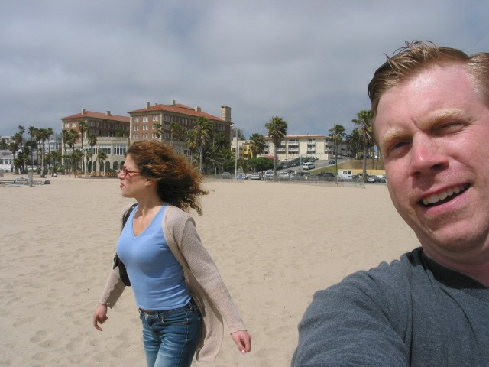

1) Homework\Hunter XP\C\Documents and Settings\Bob Hunter\Local Settings\Application Data\Microsoft\CD Burning\Hunter Pics\Christina Detsiwt

2) Homework\Hunter XP\C\Documents and Settings\Bob Hunter\Local Settings\Application Data\Microsoft\CD Burning\Hunter Pics\Christina Detsiwt\102-0201_IMG.JPG

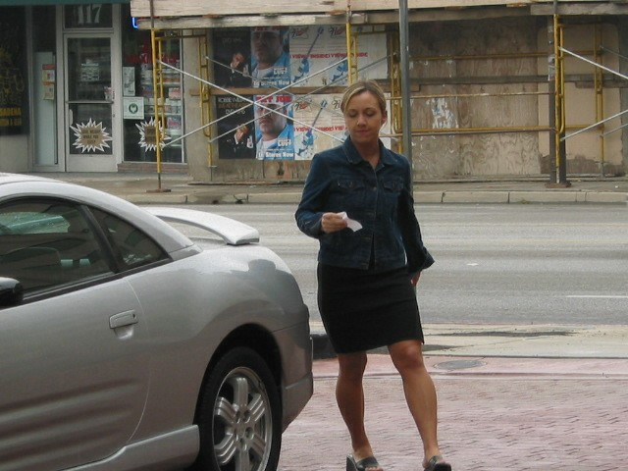

3) Homework\Hunter XP\C\Documents and Settings\Bob Hunter\Local Settings\Application Data\Microsoft\CD Burning\Hunter Pics\Christina Detsiwt\101-0188_IMG.JPG

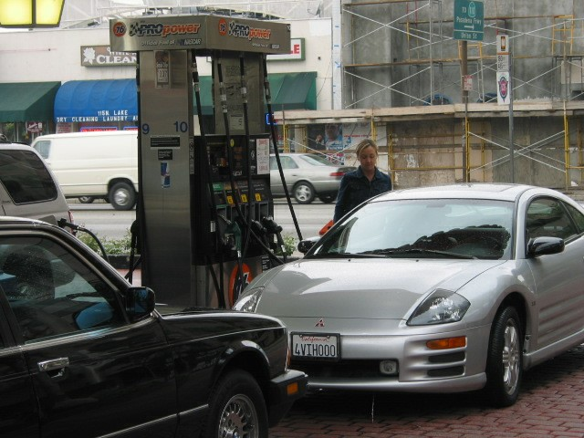

4) Homework\Hunter XP\C\Documents and Settings\Bob Hunter\Local Settings\Application Data\Microsoft\CD Burning\Hunter Pics\Christina Detsiwt\105-0576_IMG.JPG

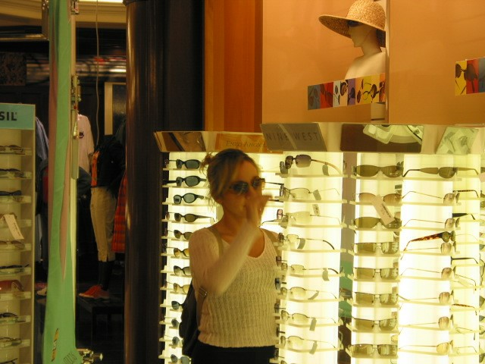

5) Homework\Hunter XP\C\Documents and Settings\Bob Hunter\Local Settings\Application Data\Microsoft\CD Burning\Hunter Pics\Christina Detsiwt\101-0184_IMG.JPG

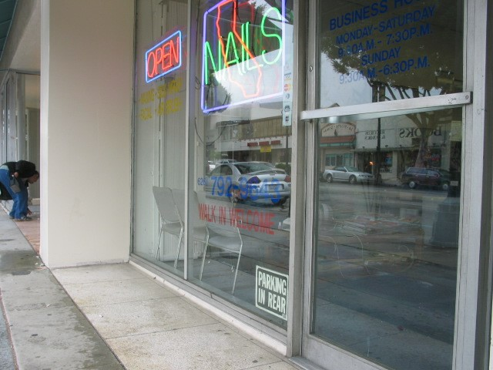

6) Homework\Hunter XP\C\Documents and Settings\Bob Hunter\Local Settings\Application Data\Microsoft\CD Burning\Hunter Pics\Christina Detsiwt\101-0191_IMG.JPG

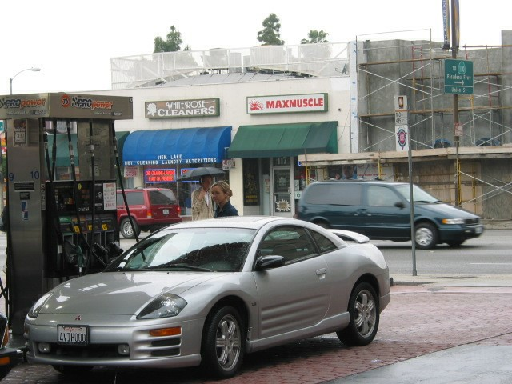

7) Homework\Hunter XP\C\Documents and Settings\Bob Hunter\Local Settings\Application Data\Microsoft\CD Burning\Hunter Pics\Christina Detsiwt\105-0580_IMG.JPG

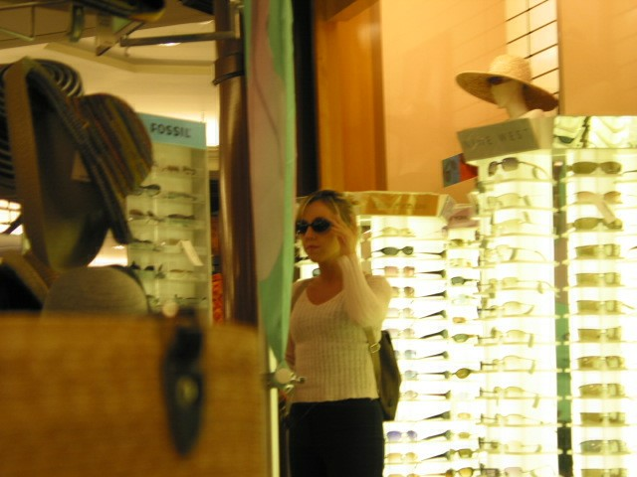

8) Homework\Hunter XP\C\Documents and Settings\Bob Hunter\Local Settings\Application Data\Microsoft\CD Burning\Hunter Pics\Christina Detsiwt\101-0193_IMG.JPG

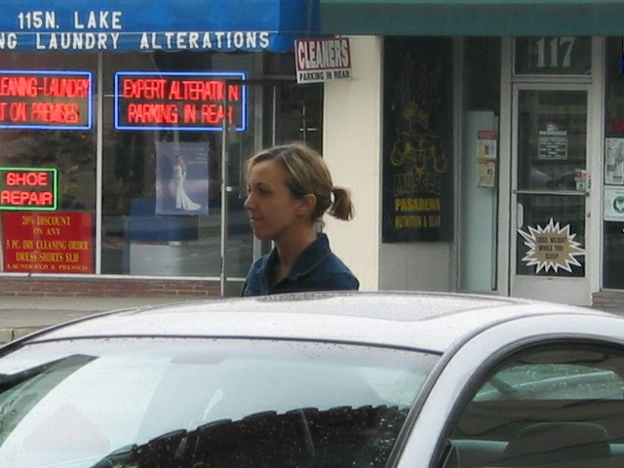

9) Homework\Hunter XP\C\Documents and Settings\Bob Hunter\Local Settings\Application Data\Microsoft\CD Burning\Hunter Pics\Christina Detsiwt\101-0194_IMG.JPG

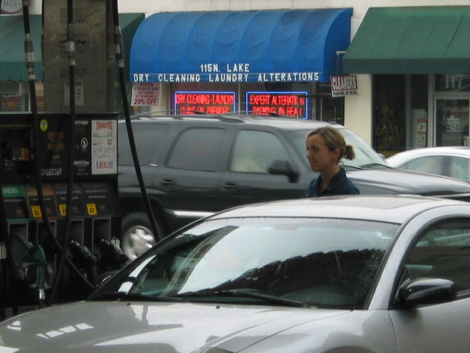

10) Homework\Hunter XP\C\Documents and Settings\Bob Hunter\Local Settings\Application Data\Microsoft\CD Burning\Hunter Pics\Christina Detsiwt\104-0401_IMG.JPG

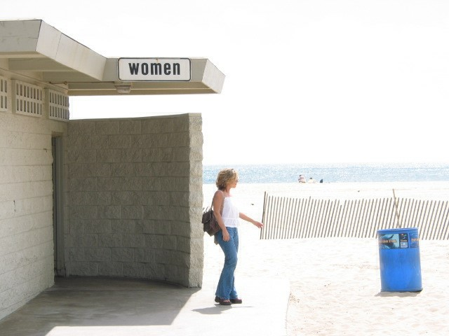

11) Homework\Hunter XP\C\Documents and Settings\Bob Hunter\Local Settings\Application Data\Microsoft\CD Burning\Hunter Pics\Christina Detsiwt\104-0403_IMG.JPG

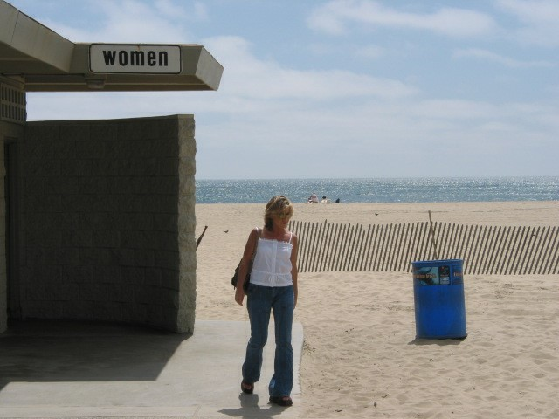

12) Homework\Hunter XP\C\Documents and Settings\Bob Hunter\Local Settings\Application Data\Microsoft\CD Burning\Hunter Pics\Christina Detsiwt\104-0404_IMG.JPG



13) Homework\Hunter XP\C\Documents and Settings\Bob Hunter\Local Settings\Application Data\Microsoft\CD Burning\Hunter Pics\Christina Detsiwt\102-0206_IMG.JPG

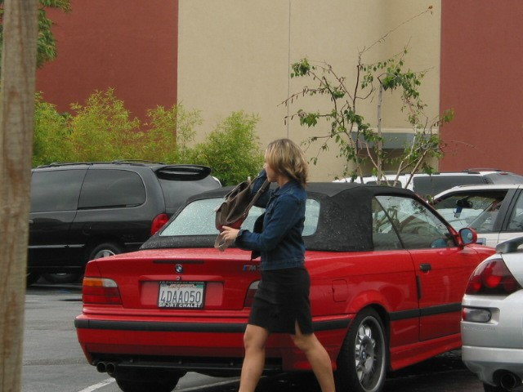

14) Homework\Hunter XP\C\Documents and Settings\Bob Hunter\Local Settings\Application Data\Microsoft\CD Burning\Hunter Pics\Christina Detsiwt\102-0205_IMG.JPG

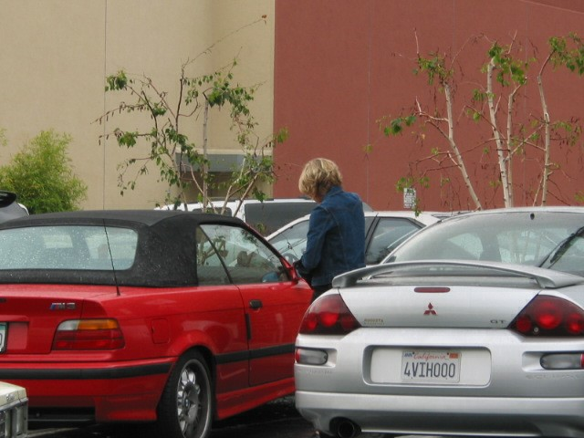

15) Homework\Hunter XP\C\Documents and Settings\Bob Hunter\Local Settings\Application Data\Microsoft\CD Burning\Hunter Pics\Christina Detsiwt\102-0214_IMG.JPG

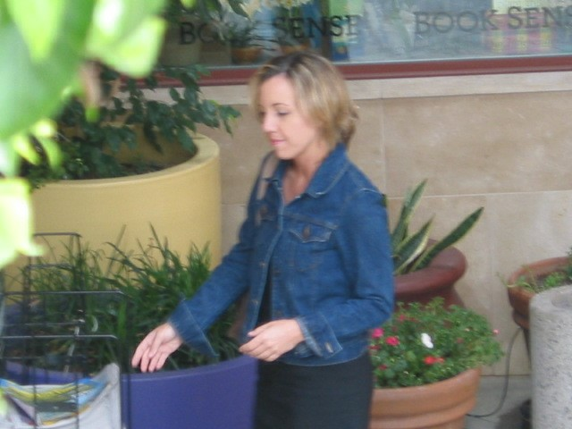

16) Homework\Hunter XP\C\Documents and Settings\Bob Hunter\Local Settings\Application Data\Microsoft\CD Burning\Hunter Pics\Christina Detsiwt\102-0212_IMG.JPG

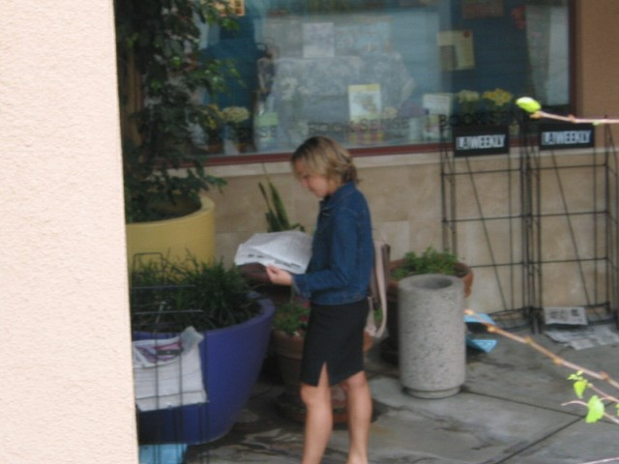

17) Homework\Hunter XP\C\Documents and Settings\Bob Hunter\Local Settings\Application Data\Microsoft\CD Burning\Hunter Pics\Christina Detsiwt\102-0225_IMG.JPG

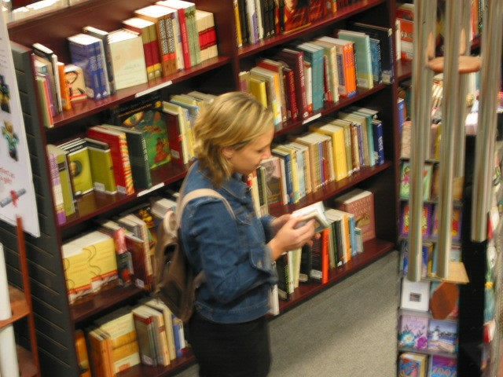

18) Homework\Hunter XP\C\Documents and Settings\Bob Hunter\Local Settings\Application Data\Microsoft\CD Burning\Hunter Pics\Christina Detsiwt\102-0227_IMG.JPG



19) Homework\Hunter XP\C\Documents and Settings\Bob Hunter\Local Settings\Application Data\Microsoft\CD Burning\Hunter Pics\Christina Detsiwt\102-0231_IMG.JPG



20) Homework\Hunter XP\C\Documents and Settings\Bob Hunter\Local Settings\Application Data\Microsoft\CD Burning\Hunter Pics\Christina Detsiwt\102-0230_IMG.JPG



21) Homework\Hunter XP\C\Documents and Settings\Bob Hunter\Local Settings\Application Data\Microsoft\CD Burning\Hunter Pics\Christina Detsiwt\102-0233_IMG.JPG



22) Homework\Hunter XP\C\Documents and Settings\Bob Hunter\Local Settings\Application Data\Microsoft\CD Burning\Hunter Pics\Christina Detsiwt\104-0421_IMG.JPG

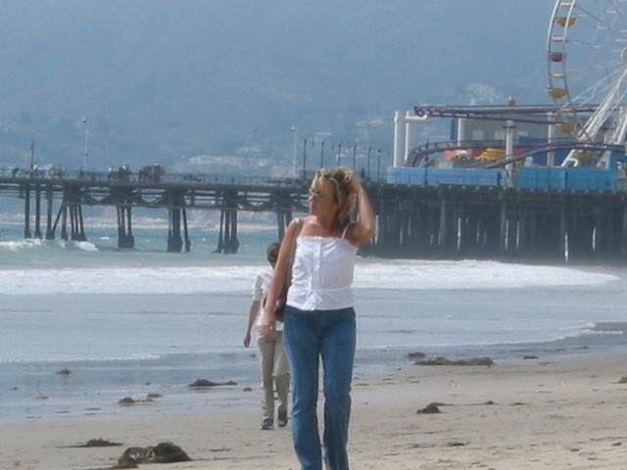

23) Homework\Hunter XP\C\Documents and Settings\Bob Hunter\Local Settings\Application Data\Microsoft\CD Burning\Hunter Pics\Christina Detsiwt\102-0237_IMG.JPG

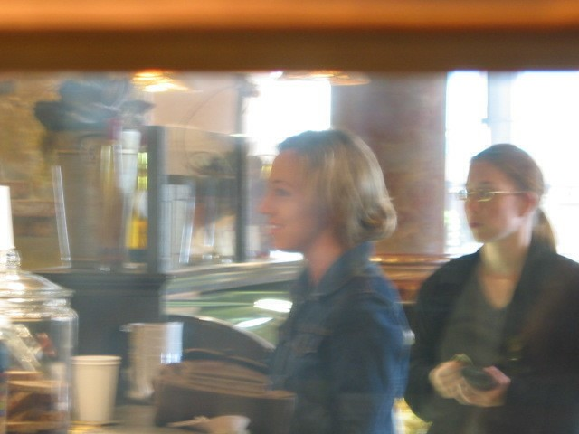

24) Homework\Hunter XP\C\Documents and Settings\Bob Hunter\Local Settings\Application Data\Microsoft\CD Burning\Hunter Pics\Christina Detsiwt\102-0246_IMG.JPG



25) Homework\Hunter XP\C\Documents and Settings\Bob Hunter\Local Settings\Application Data\Microsoft\CD Burning\Hunter Pics\Christina Detsiwt\102-0244_IMG.JPG



26) Homework\Hunter XP\C\Documents and Settings\Bob Hunter\Local Settings\Application Data\Microsoft\CD Burning\Hunter Pics\Christina Detsiwt\102-0247_IMG.JPG

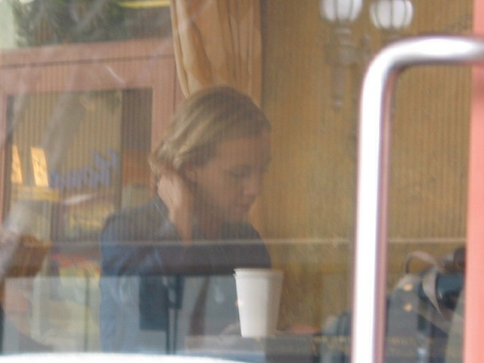

27) Homework\Hunter XP\C\Documents and Settings\Bob Hunter\Local Settings\Application Data\Microsoft\CD Burning\Hunter Pics\Christina Detsiwt\102-0251_IMG.JPG

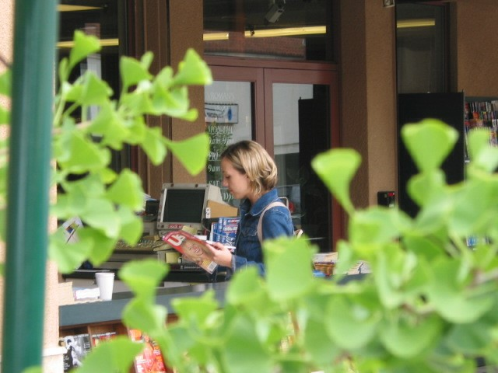

28) Homework\Hunter XP\C\Documents and Settings\Bob Hunter\Local Settings\Application Data\Microsoft\CD Burning\Hunter Pics\Christina Detsiwt\102-0250_IMG.JPG

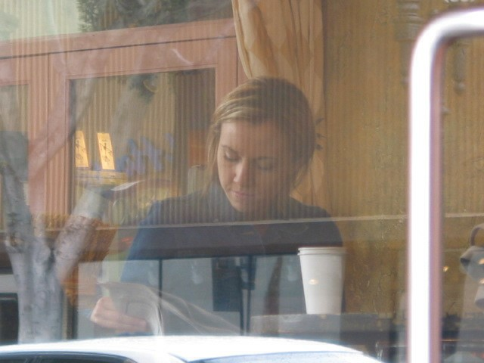

29) Homework\Hunter XP\C\Documents and Settings\Bob Hunter\Local Settings\Application Data\Microsoft\CD Burning\Hunter Pics\Christina Detsiwt\102-0254_IMG.JPG

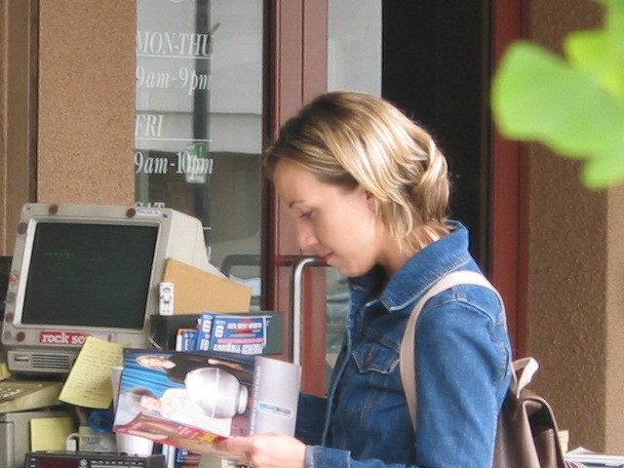

30) Homework\Hunter XP\C\Documents and Settings\Bob Hunter\Local Settings\Application Data\Microsoft\CD Burning\Hunter Pics\Christina Detsiwt\102-0257_IMG.JPG

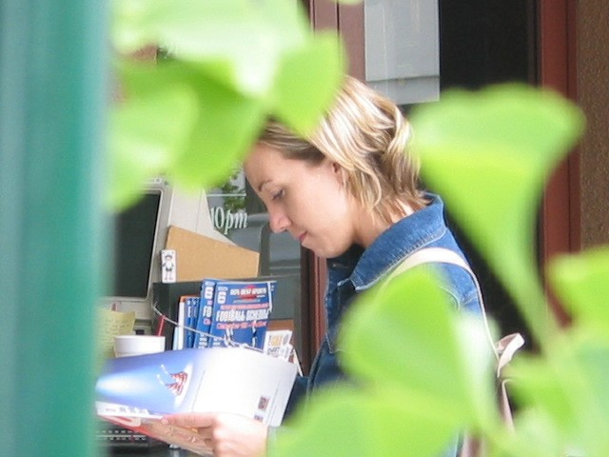

31) Homework\Hunter XP\C\Documents and Settings\Bob Hunter\Local Settings\Application Data\Microsoft\CD Burning\Hunter Pics\Christina Detsiwt\102-0261_IMG.JPG



32) Homework\Hunter XP\C\Documents and Settings\Bob Hunter\Local Settings\Application Data\Microsoft\CD Burning\Hunter Pics\Christina Detsiwt\106-0651_IMG.JPG

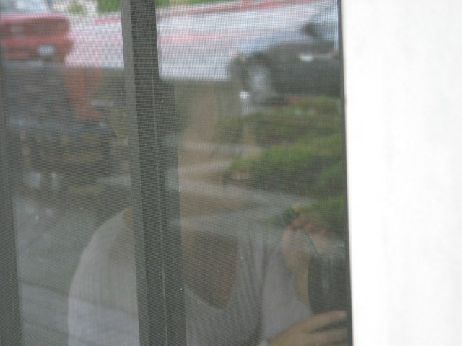

33) Homework\Hunter XP\C\Documents and Settings\Bob Hunter\Local Settings\Application Data\Microsoft\CD Burning\Hunter Pics\Christina Detsiwt\106-0654_IMG.JPG

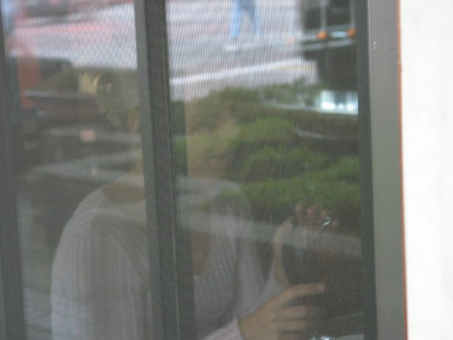

34) Homework\Hunter XP\C\Documents and Settings\Bob Hunter\Local Settings\Application Data\Microsoft\CD Burning\Hunter Pics\Christina Detsiwt\102-0265_IMG.JPG

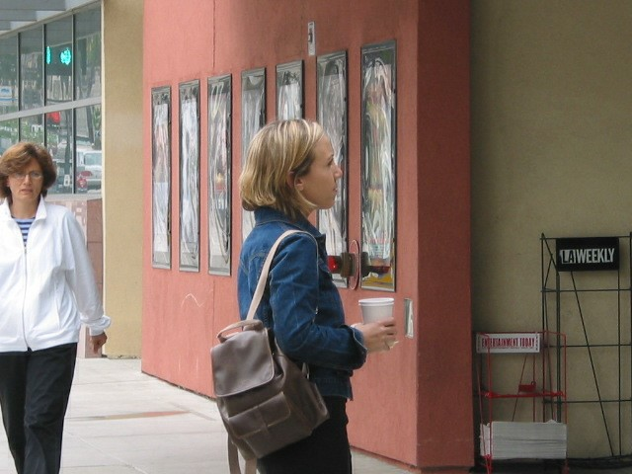

35) Homework\Hunter XP\C\Documents and Settings\Bob Hunter\Local Settings\Application Data\Microsoft\CD Burning\Hunter Pics\Christina Detsiwt\106-0653_IMG.JPG



36) Homework\Hunter XP\C\Documents and Settings\Bob Hunter\Local Settings\Application Data\Microsoft\CD Burning\Hunter Pics\Christina Detsiwt\102-0264_IMG.JPG

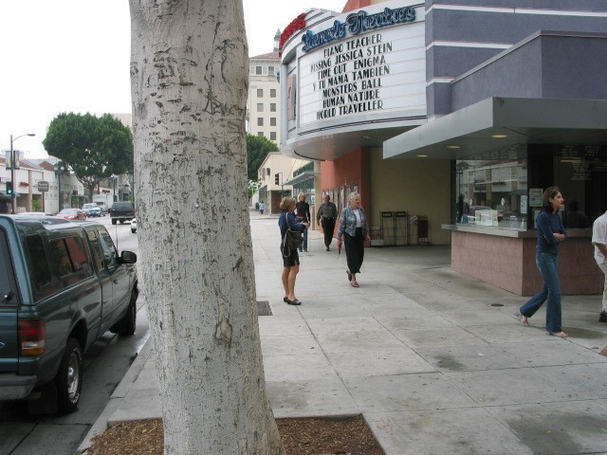

37) Homework\Hunter XP\C\Documents and Settings\Bob Hunter\Local Settings\Application Data\Microsoft\CD Burning\Hunter Pics\Christina Detsiwt\102-0262_IMG.JPG



38) Homework\Hunter XP\C\Documents and Settings\Bob Hunter\Local Settings\Application Data\Microsoft\CD Burning\Hunter Pics\Christina Detsiwt\106-0650_IMG.JPG

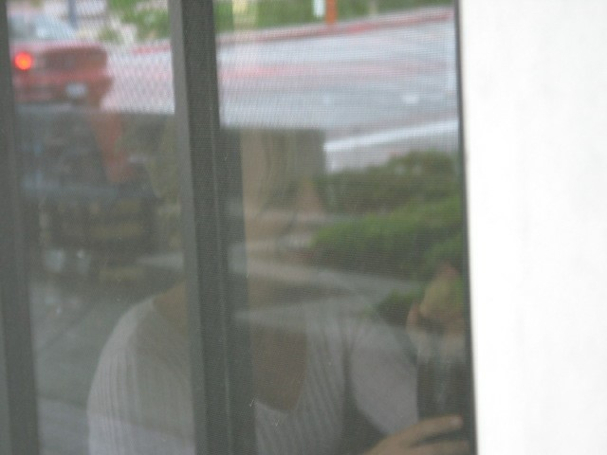

39) Homework\Hunter XP\C\Documents and Settings\Bob Hunter\Local Settings\Application Data\Microsoft\CD Burning\Hunter Pics\Christina Detsiwt\102-0271_IMG.JPG



40) Homework\Hunter XP\C\Documents and Settings\Bob Hunter\Local Settings\Application Data\Microsoft\CD Burning\Hunter Pics\Christina Detsiwt\102-0270_IMG.JPG

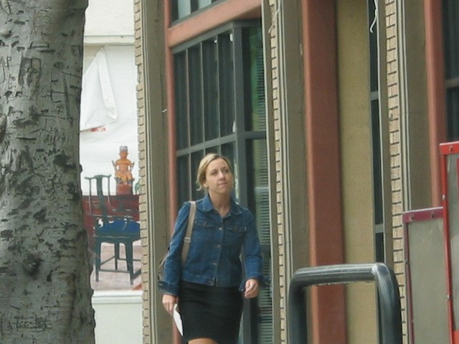

41) Homework\Hunter XP\C\Documents and Settings\Bob Hunter\Local Settings\Application Data\Microsoft\CD Burning\Hunter Pics\Christina Detsiwt\102-0276_IMG.JPG

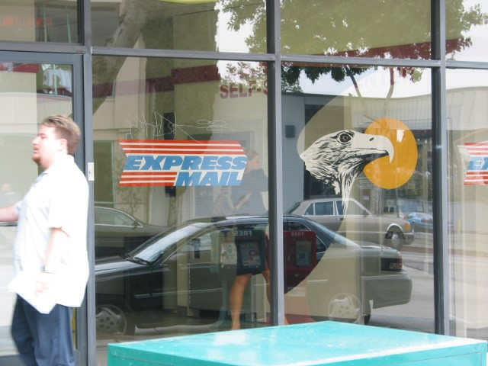

42) Homework\Hunter XP\C\Documents and Settings\Bob Hunter\Local Settings\Application Data\Microsoft\CD Burning\Hunter Pics\Christina Detsiwt\102-0274_IMG.JPG

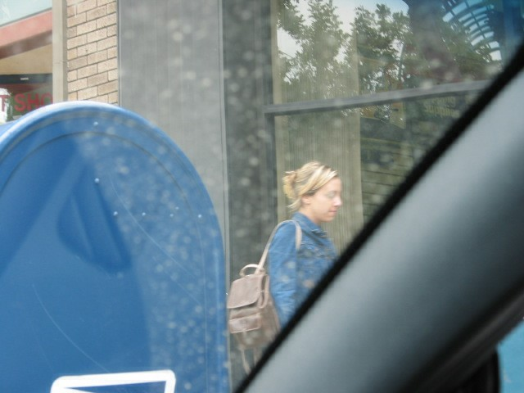

43) Homework\Hunter XP\C\Documents and Settings\Bob Hunter\Local Settings\Application Data\Microsoft\CD Burning\Hunter Pics\Christina Detsiwt\102-0280_IMG.JPG



44) Homework\Hunter XP\C\Documents and Settings\Bob Hunter\Local Settings\Application Data\Microsoft\CD Burning\Hunter Pics\Christina Detsiwt\102-0283_IMG.JPG

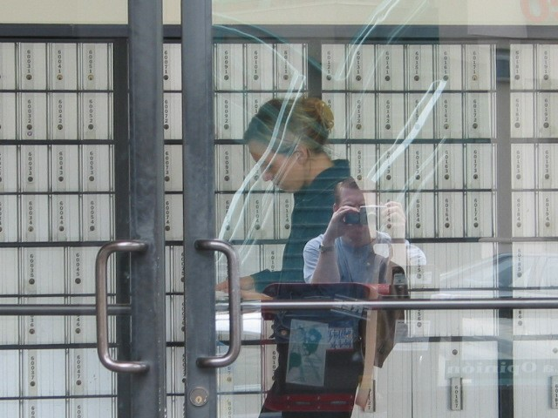

45) Homework\Hunter XP\C\Documents and Settings\Bob Hunter\Local Settings\Application Data\Microsoft\CD Burning\Hunter Pics\Christina Detsiwt\102-0286_IMG.JPG

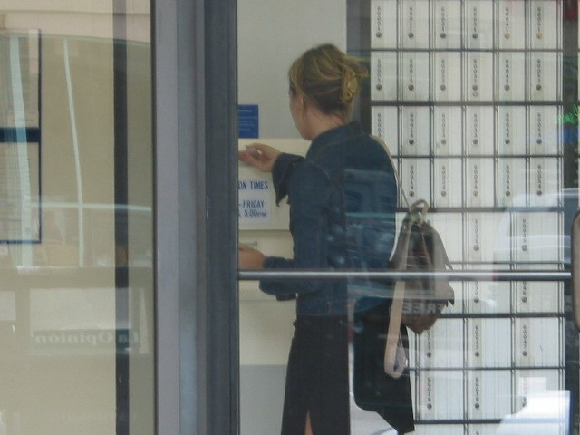

46) Homework\Hunter XP\C\Documents and Settings\Bob Hunter\Local Settings\Application Data\Microsoft\CD Burning\Hunter Pics\Christina Detsiwt\102-0284_IMG.JPG

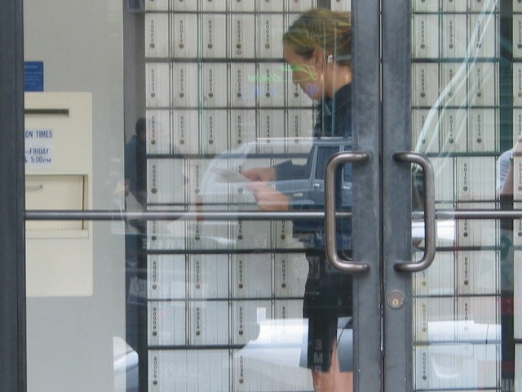

47) Homework\Hunter XP\C\Documents and Settings\Bob Hunter\Local Settings\Application Data\Microsoft\CD Burning\Hunter Pics\Christina Detsiwt\107-0710_IMG.JPG



48) Homework\Hunter XP\C\Documents and Settings\Bob Hunter\Local Settings\Application Data\Microsoft\CD Burning\Hunter Pics\Christina Detsiwt\102-0209_IMG.JPG

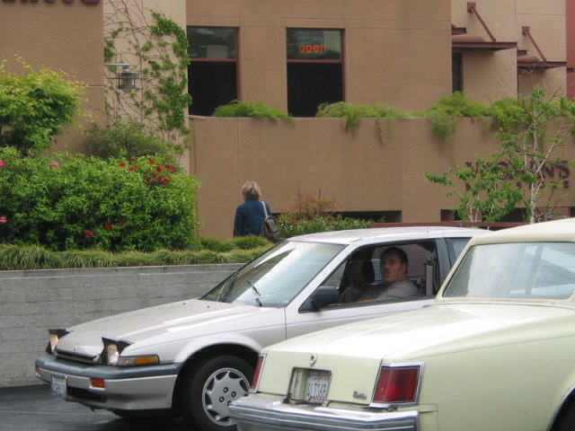

49) Homework\Hunter XP\C\Documents and Settings\Bob Hunter\Local Settings\Application Data\Microsoft\CD Burning\Hunter Pics\Christina Detsiwt\102-0208_IMG.JPG

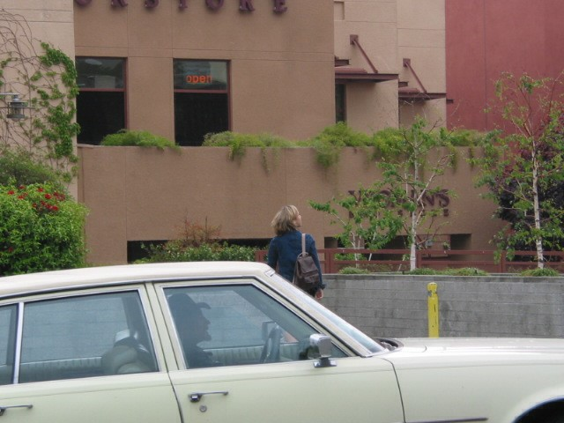

50) Homework\Hunter XP\C\Documents and Settings\Bob Hunter\Local Settings\Application Data\Microsoft\CD Burning\Hunter Pics\Christina Detsiwt\102-0218_IMG.JPG



51) Homework\Hunter XP\C\Documents and Settings\Bob Hunter\Local Settings\Application Data\Microsoft\CD Burning\Hunter Pics\Christina Detsiwt\102-0229_IMG.JPG

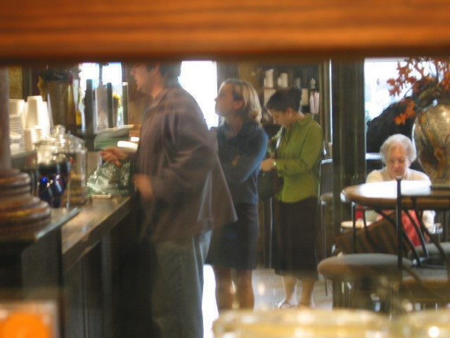

52) Homework\Hunter XP\C\Documents and Settings\Bob Hunter\Local Settings\Application Data\Microsoft\CD Burning\Hunter Pics\Christina Detsiwt\102-0248_IMG.JPG

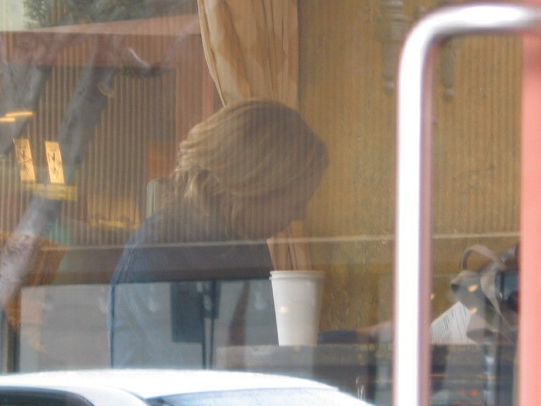

53) Homework\Hunter XP\C\Documents and Settings\Bob Hunter\Local Settings\Application Data\Microsoft\CD Burning\Hunter Pics\Christina Detsiwt\102-0269_IMG.JPG

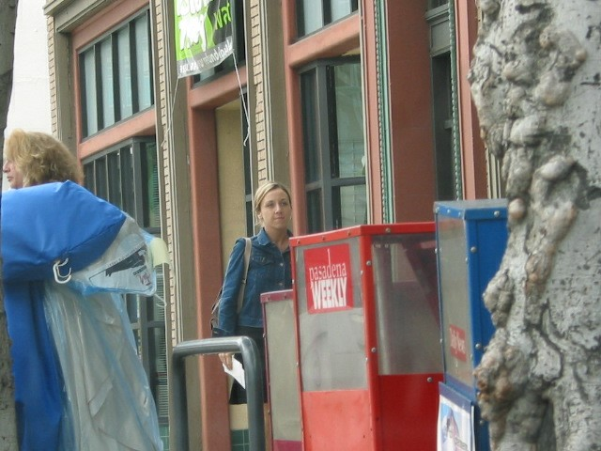

54) Homework\Hunter XP\C\Documents and Settings\Bob Hunter\Local Settings\Application Data\Microsoft\CD Burning\Hunter Pics\Christina Detsiwt\106-0657_IMG.JPG



55) Homework\Hunter XP\C\Documents and Settings\Bob Hunter\Local Settings\Application Data\Microsoft\CD Burning\Hunter Pics\Christina Detsiwt\102-0268_IMG.JPG

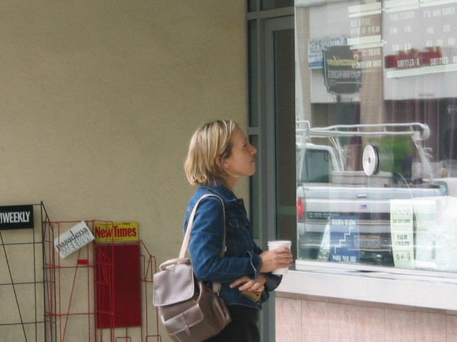

56) Homework\Hunter XP\C\Documents and Settings\Bob Hunter\Local Settings\Application Data\Microsoft\CD Burning\Hunter Pics\Christina Detsiwt\106-0659_IMG.JPG



57) Homework\Hunter XP\C\Documents and Settings\Bob Hunter\Local Settings\Application Data\Microsoft\CD Burning\Hunter Pics\Christina Detsiwt\102-0279_IMG.JPG

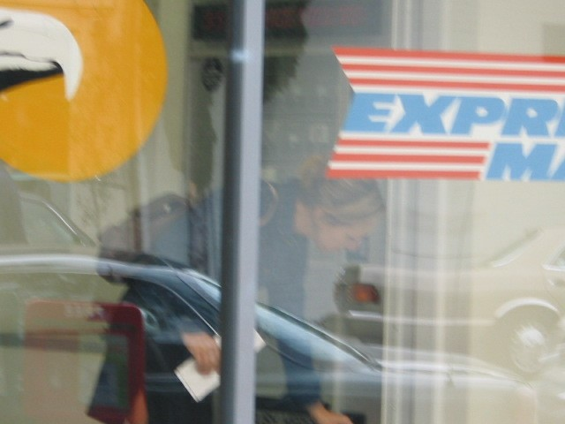

58) Homework\Hunter XP\C\Documents and Settings\Bob Hunter\Local Settings\Application Data\Microsoft\CD Burning\Hunter Pics\Christina Detsiwt\106-0667_IMG.JPG

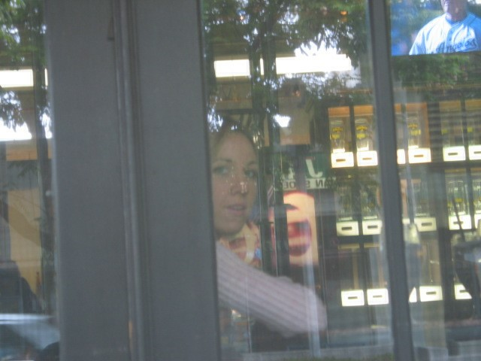

59) Homework\Hunter XP\C\Documents and Settings\Bob Hunter\Local Settings\Application Data\Microsoft\CD Burning\Hunter Pics\Christina Detsiwt\106-0666_IMG.JPG

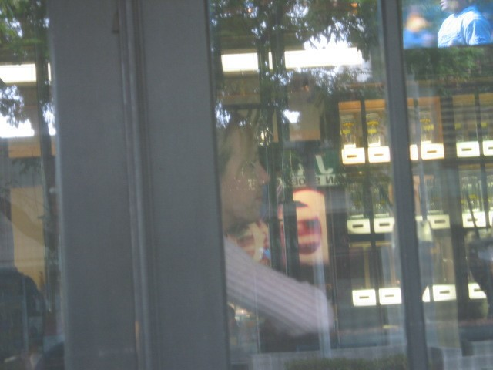

60) Homework\Hunter XP\C\Documents and Settings\Bob Hunter\Local Settings\Application Data\Microsoft\CD Burning\Hunter Pics\Christina Detsiwt\103-0370_IMG.JPG

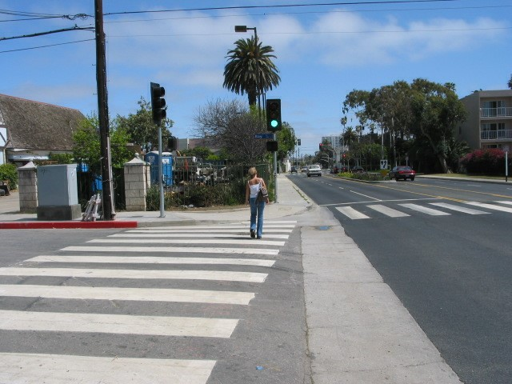

61) Homework\Hunter XP\C\Documents and Settings\Bob Hunter\Local Settings\Application Data\Microsoft\CD Burning\Hunter Pics\Christina Detsiwt\103-0371_IMG.JPG

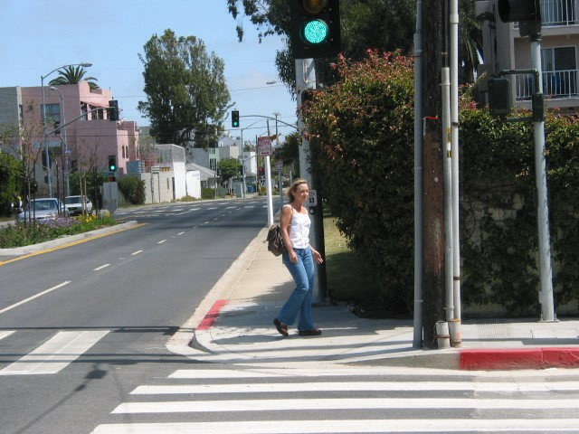

62) Homework\Hunter XP\C\Documents and Settings\Bob Hunter\Local Settings\Application Data\Microsoft\CD Burning\Hunter Pics\Christina Detsiwt\103-0377_IMG.JPG



63) Homework\Hunter XP\C\Documents and Settings\Bob Hunter\Local Settings\Application Data\Microsoft\CD Burning\Hunter Pics\Christina Detsiwt\103-0374_IMG.JPG

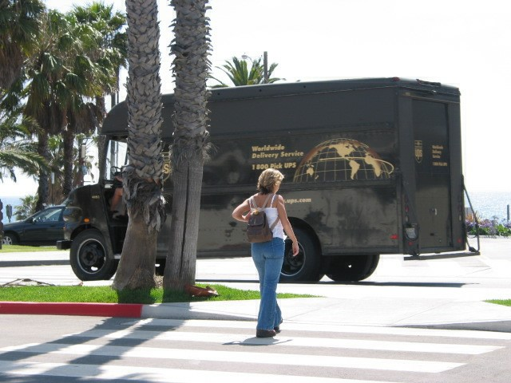

64) Homework\Hunter XP\C\Documents and Settings\Bob Hunter\Local Settings\Application Data\Microsoft\CD Burning\Hunter Pics\Christina Detsiwt\103-0375_IMG.JPG

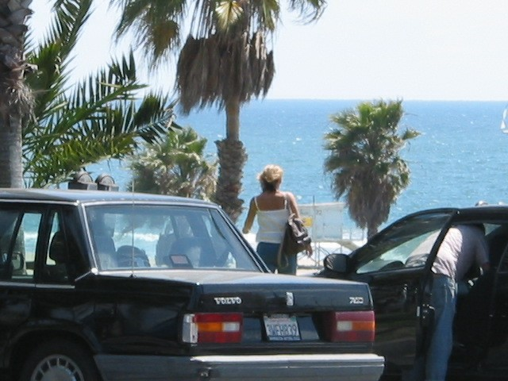

65) Homework\Hunter XP\C\Documents and Settings\Bob Hunter\Local Settings\Application Data\Microsoft\CD Burning\Hunter Pics\Christina Detsiwt\103-0372_IMG.JPG

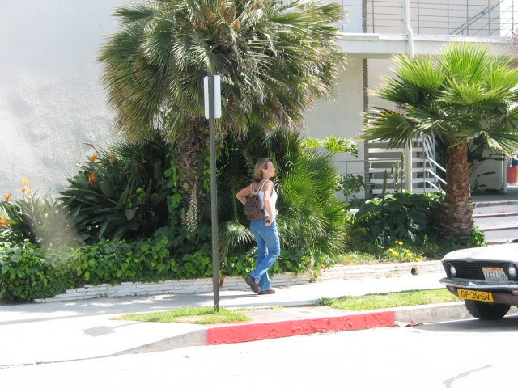

66) Homework\Hunter XP\C\Documents and Settings\Bob Hunter\Local Settings\Application Data\Microsoft\CD Burning\Hunter Pics\Christina Detsiwt\103-0380_IMG.JPG



67) Homework\Hunter XP\C\Documents and Settings\Bob Hunter\Local Settings\Application Data\Microsoft\CD Burning\Hunter Pics\Christina Detsiwt\103-0386_IMG.JPG

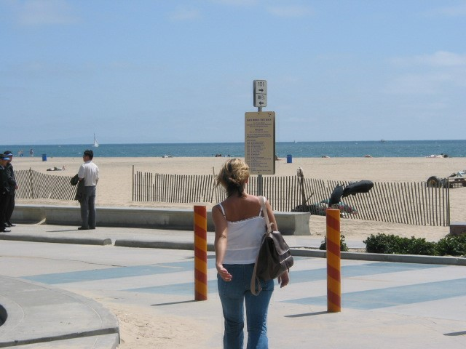

68) Homework\Hunter XP\C\Documents and Settings\Bob Hunter\Local Settings\Application Data\Microsoft\CD Burning\Hunter Pics\Christina Detsiwt\103-0385_IMG.JPG

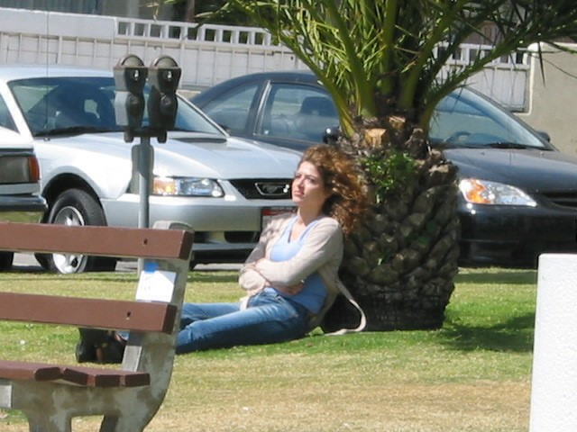

69) Homework\Hunter XP\C\Documents and Settings\Bob Hunter\Local Settings\Application Data\Microsoft\CD Burning\Hunter Pics\Christina Detsiwt\103-0383_IMG.JPG

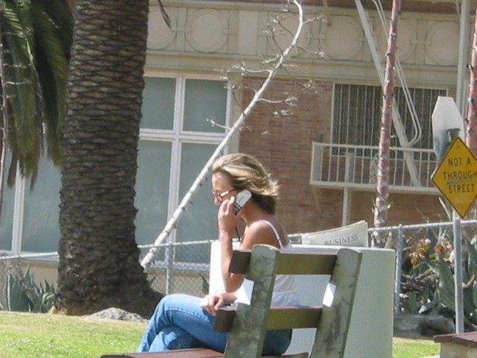

70) Homework\Hunter XP\C\Documents and Settings\Bob Hunter\Local Settings\Application Data\Microsoft\CD Burning\Hunter Pics\Christina Detsiwt\103-0391_IMG.JPG

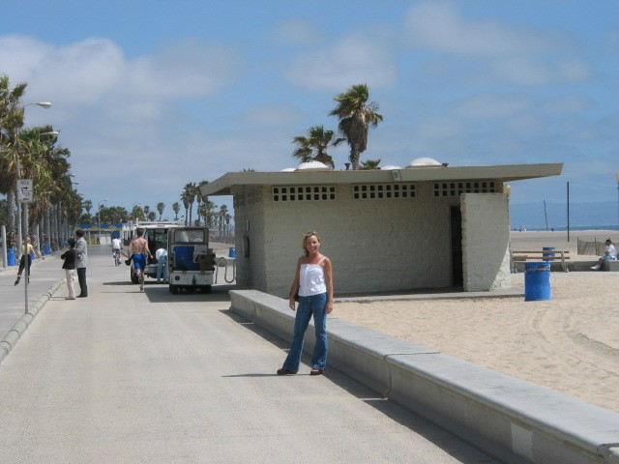

71) Homework\Hunter XP\C\Documents and Settings\Bob Hunter\Local Settings\Application Data\Microsoft\CD Burning\Hunter Pics\Christina Detsiwt\103-0394_IMG.JPG

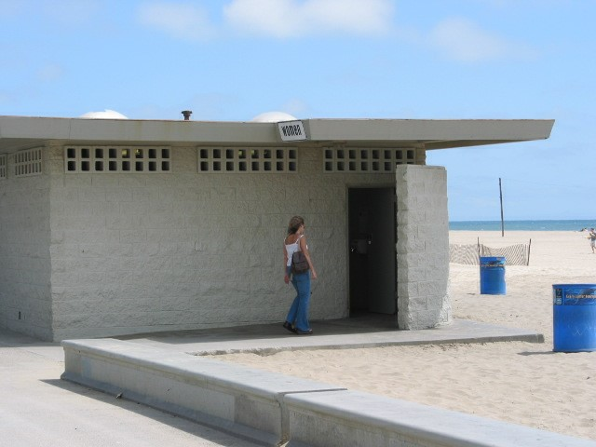

72) Homework\Hunter XP\C\Documents and Settings\Bob Hunter\Local Settings\Application Data\Microsoft\CD Burning\Hunter Pics\Christina Detsiwt\103-0395_IMG.JPG

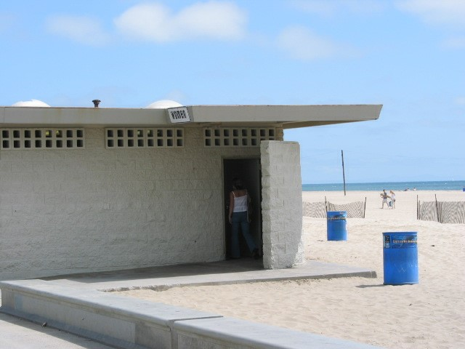

73) Homework\Hunter XP\C\Documents and Settings\Bob Hunter\Local Settings\Application Data\Microsoft\CD Burning\Hunter Pics\Christina Detsiwt\103-0392_IMG.JPG

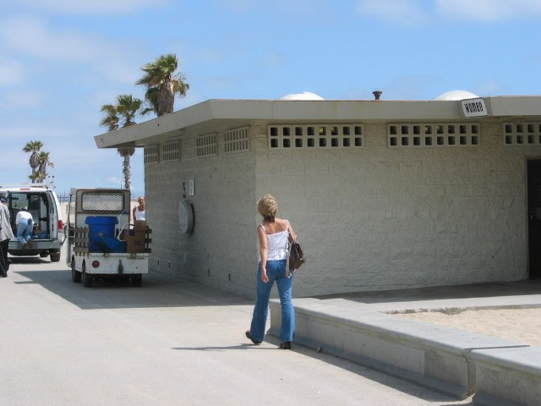

74) Homework\Hunter XP\C\Documents and Settings\Bob Hunter\Local Settings\Application Data\Microsoft\CD Burning\Hunter Pics\Christina Detsiwt\103-0388_IMG.JPG

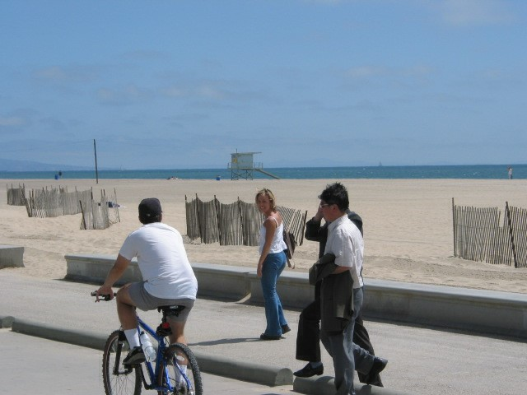

75) Homework\Hunter XP\C\Documents and Settings\Bob Hunter\Local Settings\Application Data\Microsoft\CD Burning\Hunter Pics\Christina Detsiwt\103-0389_IMG.JPG

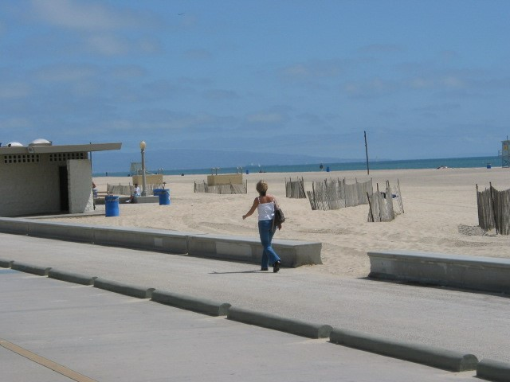

76) Homework\Hunter XP\C\Documents and Settings\Bob Hunter\Local Settings\Application Data\Microsoft\CD Burning\Hunter Pics\Christina Detsiwt\103-0398_IMG.JPG

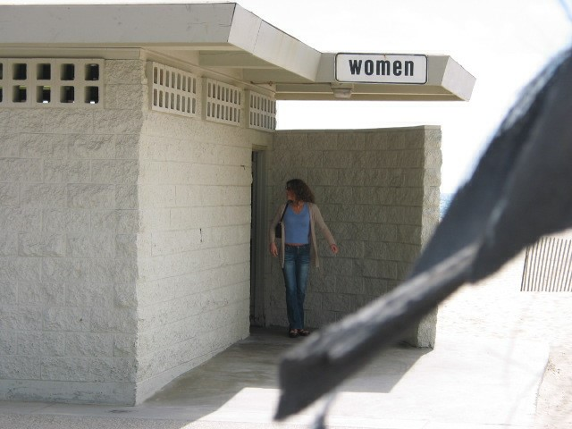

77) Homework\Hunter XP\C\Documents and Settings\Bob Hunter\Local Settings\Application Data\Microsoft\CD Burning\Hunter Pics\Christina Detsiwt\103-0399_IMG.JPG

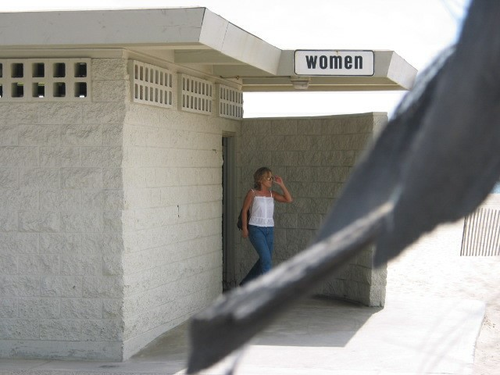

78) Homework\Hunter XP\C\Documents and Settings\Bob Hunter\Local Settings\Application Data\Microsoft\CD Burning\Hunter Pics\Christina Detsiwt\104-0410_IMG.JPG



79) Homework\Hunter XP\C\Documents and Settings\Bob Hunter\Local Settings\Application Data\Microsoft\CD Burning\Hunter Pics\Christina Detsiwt\104-0412_IMG.JPG



80) Homework\Hunter XP\C\Documents and Settings\Bob Hunter\Local Settings\Application Data\Microsoft\CD Burning\Hunter Pics\Christina Detsiwt\104-0415_IMG.JPG

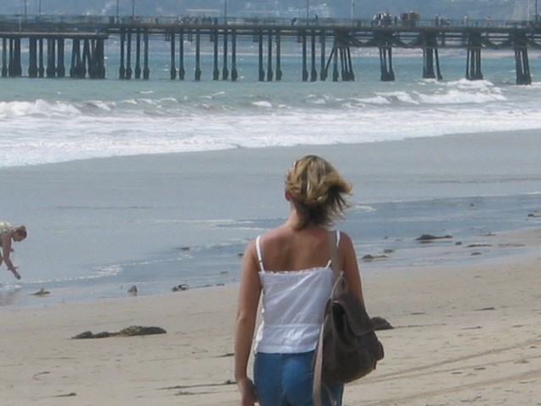

81) Homework\Hunter XP\C\Documents and Settings\Bob Hunter\Local Settings\Application Data\Microsoft\CD Burning\Hunter Pics\Christina Detsiwt\104-0413_IMG.JPG



82) Homework\Hunter XP\C\Documents and Settings\Bob Hunter\Local Settings\Application Data\Microsoft\CD Burning\Hunter Pics\Christina Detsiwt\104-0416_IMG.JPG

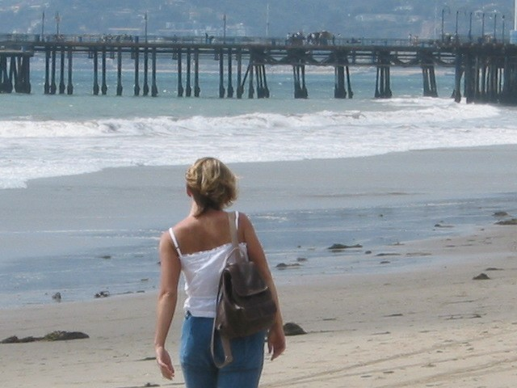

83) Homework\Hunter XP\C\Documents and Settings\Bob Hunter\Local Settings\Application Data\Microsoft\CD Burning\Hunter Pics\Christina Detsiwt\104-0411_IMG.JPG



84) Homework\Hunter XP\C\Documents and Settings\Bob Hunter\Local Settings\Application Data\Microsoft\CD Burning\Hunter Pics\Christina Detsiwt\104-0422_IMG.JPG



85) Homework\Hunter XP\C\Documents and Settings\Bob Hunter\Local Settings\Application Data\Microsoft\CD Burning\Hunter Pics\Christina Detsiwt\104-0424_IMG.JPG



86) Homework\Hunter XP\C\Documents and Settings\Bob Hunter\Local Settings\Application Data\Microsoft\CD Burning\Hunter Pics\Christina Detsiwt\104-0432_IMG.JPG

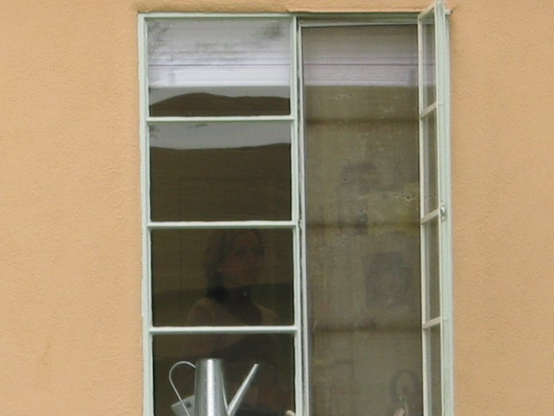

87) Homework\Hunter XP\C\Documents and Settings\Bob Hunter\Local Settings\Application Data\Microsoft\CD Burning\Hunter Pics\Christina Detsiwt\104-0434_IMG.JPG



88) Homework\Hunter XP\C\Documents and Settings\Bob Hunter\Local Settings\Application Data\Microsoft\CD Burning\Hunter Pics\Christina Detsiwt\104-0443_IMG.JPG

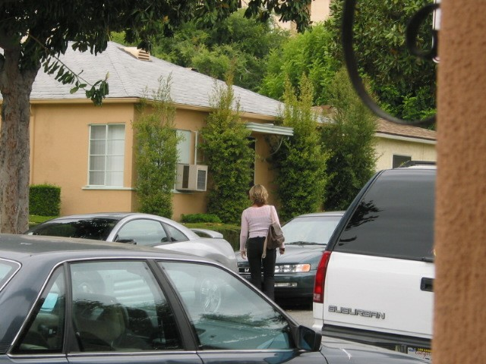

89) Homework\Hunter XP\C\Documents and Settings\Bob Hunter\Local Settings\Application Data\Microsoft\CD Burning\Hunter Pics\Christina Detsiwt\104-0441_IMG.JPG

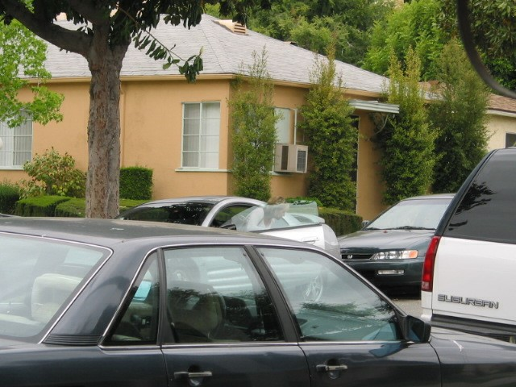

90) Homework\Hunter XP\C\Documents and Settings\Bob Hunter\Local Settings\Application Data\Microsoft\CD Burning\Hunter Pics\Christina Detsiwt\104-0455_IMG.JPG

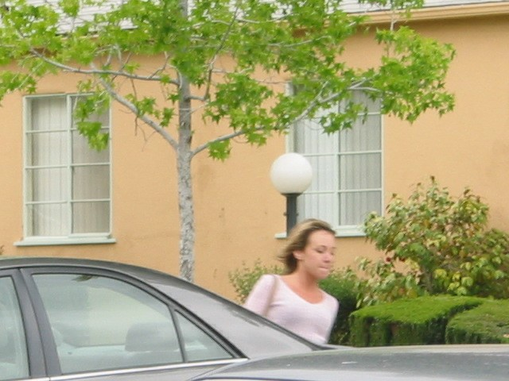

91) Homework\Hunter XP\C\Documents and Settings\Bob Hunter\Local Settings\Application Data\Microsoft\CD Burning\Hunter Pics\Christina Detsiwt\104-0453_IMG.JPG

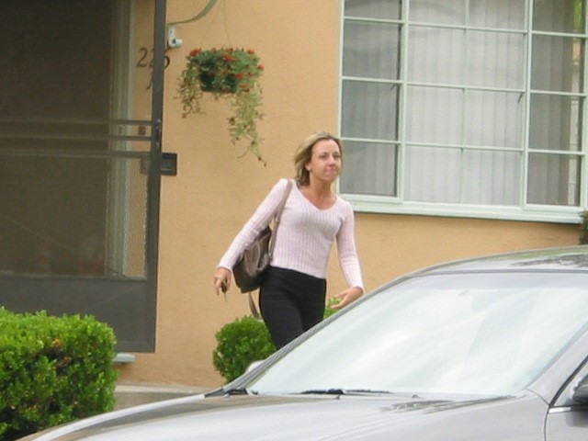

92) Homework\Hunter XP\C\Documents and Settings\Bob Hunter\Local Settings\Application Data\Microsoft\CD Burning\Hunter Pics\Christina Detsiwt\104-0451_IMG.JPG

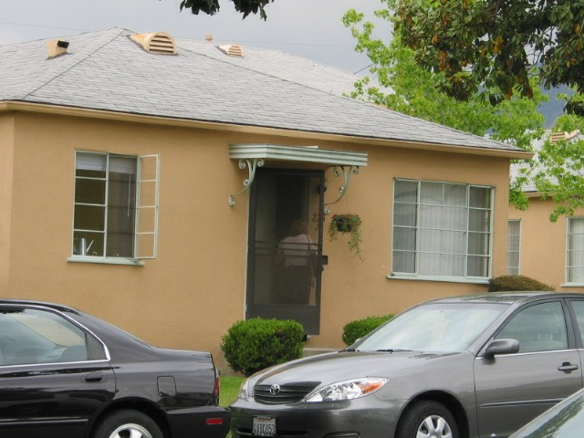

93) Homework\Hunter XP\C\Documents and Settings\Bob Hunter\Local Settings\Application Data\Microsoft\CD Burning\Hunter Pics\Christina Detsiwt\104-0462_IMG.JPG

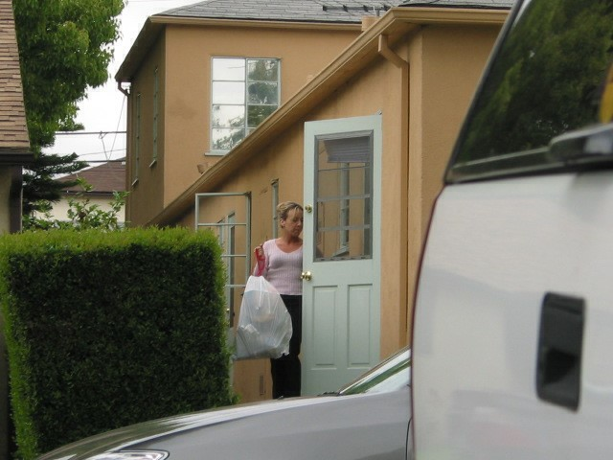

94) Homework\Hunter XP\C\Documents and Settings\Bob Hunter\Local Settings\Application Data\Microsoft\CD Burning\Hunter Pics\Christina Detsiwt\104-0466_IMG.JPG

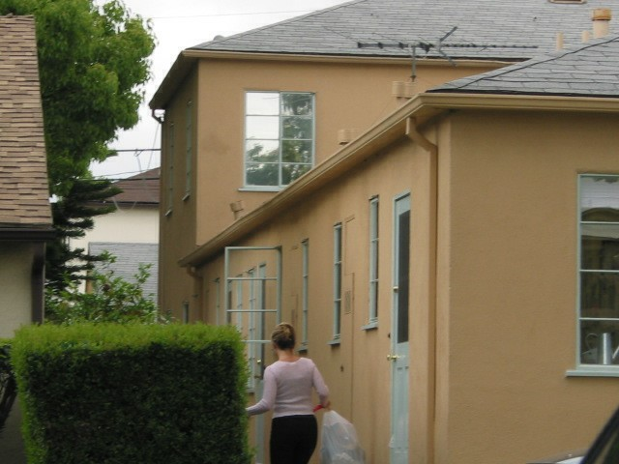

95) Homework\Hunter XP\C\Documents and Settings\Bob Hunter\Local Settings\Application Data\Microsoft\CD Burning\Hunter Pics\Christina Detsiwt\104-0461_IMG.JPG

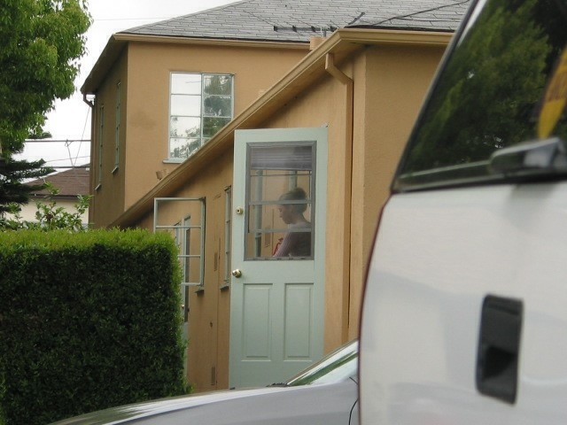

96) Homework\Hunter XP\C\Documents and Settings\Bob Hunter\Local Settings\Application Data\Microsoft\CD Burning\Hunter Pics\Christina Detsiwt\104-0473_IMG.JPG

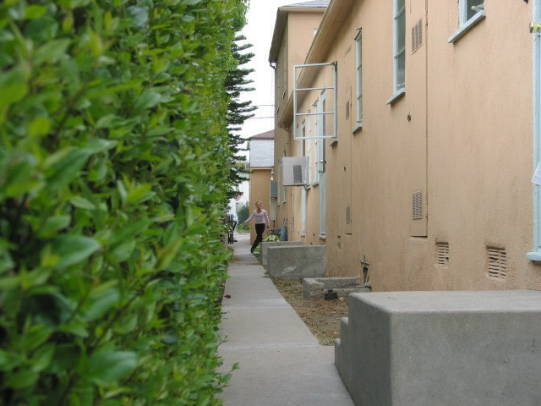

97) Homework\Hunter XP\C\Documents and Settings\Bob Hunter\Local Settings\Application Data\Microsoft\CD Burning\Hunter Pics\Christina Detsiwt\104-0408_IMG.JPG



98) Homework\Hunter XP\C\Documents and Settings\Bob Hunter\Local Settings\Application Data\Microsoft\CD Burning\Hunter Pics\Christina Detsiwt\104-0438_IMG.JPG

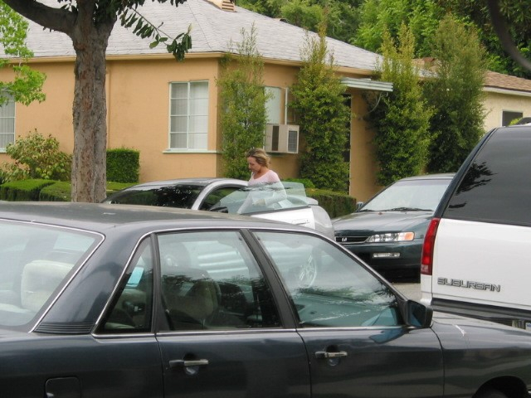

99) Homework\Hunter XP\C\Documents and Settings\Bob Hunter\Local Settings\Application Data\Microsoft\CD Burning\Hunter Pics\Christina Detsiwt\104-0449_IMG.JPG

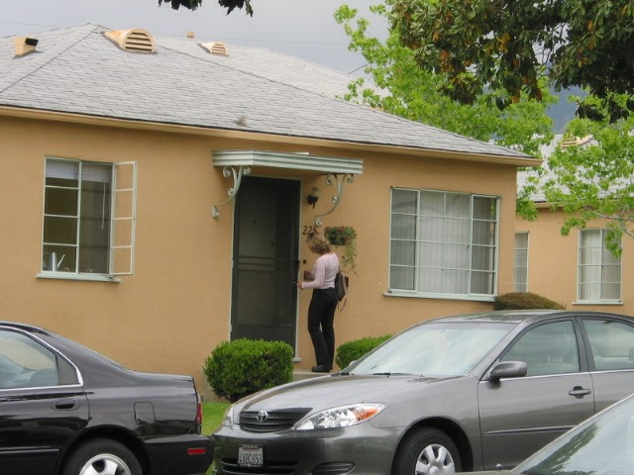

100) Homework\Hunter XP\C\Documents and Settings\Bob Hunter\Local Settings\Application Data\Microsoft\CD Burning\Hunter Pics\Christina Detsiwt\104-0448_IMG.JPG

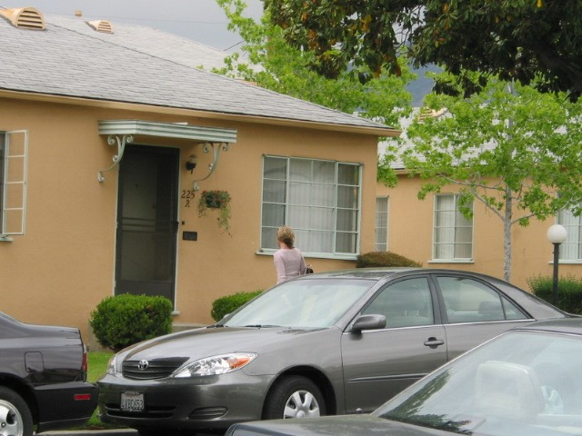

101) Homework\Hunter XP\C\Documents and Settings\Bob Hunter\Local Settings\Application Data\Microsoft\CD Burning\Hunter Pics\Christina Detsiwt\104-0458_IMG.JPG

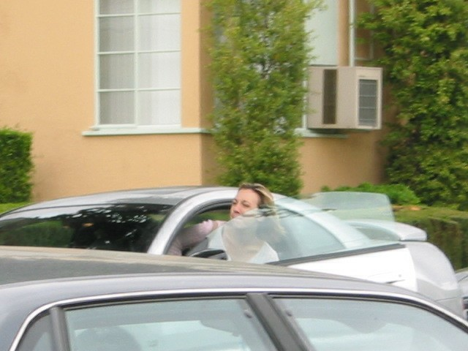

102) Homework\Hunter XP\C\Documents and Settings\Bob Hunter\Local Settings\Application Data\Microsoft\CD Burning\Hunter Pics\Christina Detsiwt\104-0457_IMG.JPG

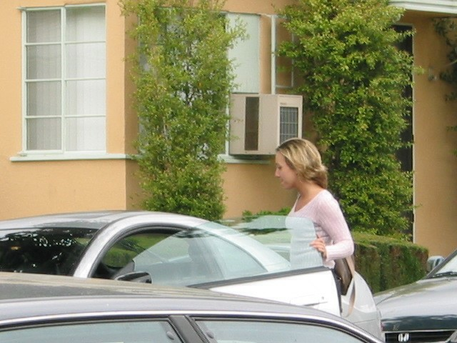

103) Homework\Hunter XP\C\Documents and Settings\Bob Hunter\Local Settings\Application Data\Microsoft\CD Burning\Hunter Pics\Christina Detsiwt\104-0477_IMG.JPG

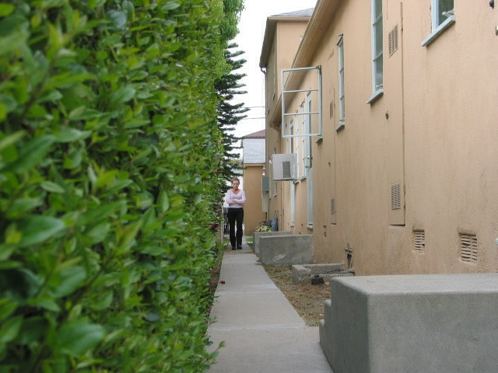

104) Homework\Hunter XP\C\Documents and Settings\Bob Hunter\Local Settings\Temporary Internet Files\Content.IE5\042WFPGU\104-0436_IMG[2].jpg



105) Homework\Hunter XP\C\Documents and Settings\Bob Hunter\Local Settings\Temporary Internet Files\Content.IE5\042WFPGU\102-0271_IMG[1].jpg



106) Homework\Hunter XP\C\Documents and Settings\Bob Hunter\Local Settings\Temporary Internet Files\Content.IE5\042WFPGU\103-0349_IMG[1].jpg

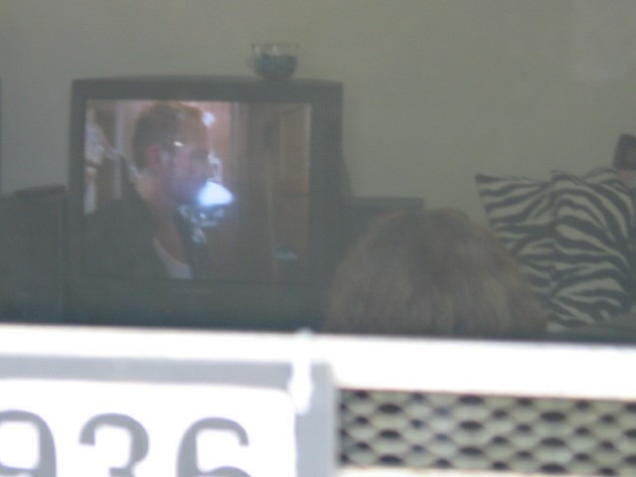

107) Homework\Hunter XP\C\Documents and Settings\Bob Hunter\Local Settings\Temporary Internet Files\Content.IE5\042WFPGU\103-0361_IMG[1].jpg



108) Homework\Hunter XP\C\Documents and Settings\Bob Hunter\Local Settings\Temporary Internet Files\Content.IE5\042WFPGU\104-0430_IMG[1].jpg



109) Homework\Hunter XP\C\Documents and Settings\Bob Hunter\Local Settings\Temporary Internet Files\Content.IE5\042WFPGU\101-0175_IMG[1].jpg



110) Homework\Hunter XP\C\Documents and Settings\Bob Hunter\Local Settings\Temporary Internet Files\Content.IE5\042WFPGU\104-0436_IMG[1].jpg



111) Homework\Hunter XP\C\Documents and Settings\Bob Hunter\Local Settings\Temporary Internet Files\Content.IE5\042WFPGU\102-0244_IMG[1].jpg



112) Homework\Hunter XP\C\Documents and Settings\Bob Hunter\Local Settings\Temporary Internet Files\Content.IE5\042WFPGU\101-0195_IMG[1].jpg



113) Homework\Hunter XP\C\Documents and Settings\Bob Hunter\Local Settings\Temporary Internet Files\Content.IE5\042WFPGU\102-0206_IMG[2].jpg



114) Homework\Hunter XP\C\Documents and Settings\Bob Hunter\Local Settings\Temporary Internet Files\Content.IE5\042WFPGU\102-0235_IMG[1].jpg



115) Homework\Hunter XP\C\Documents and Settings\Bob Hunter\Local Settings\Temporary Internet Files\Content.IE5\042WFPGU\102-0206_IMG[1].jpg



116) Homework\Hunter XP\C\Documents and Settings\Bob Hunter\Local Settings\Temporary Internet Files\Content.IE5\8XGPQD6L\102-0283_IMG[1].jpg



1) Homework\Hunter XP\C\Documents and Settings\Bob Hunter\Local Settings\Application Data\Microsoft\CD Burning\Hunter Pics\Sabrina Dewercs

2) Homework\Hunter XP\C\Documents and Settings\Bob Hunter\Local Settings\Application Data\Microsoft\CD Burning\Hunter Pics\Sabrina Dewercs\105-0534_IMG.JPG

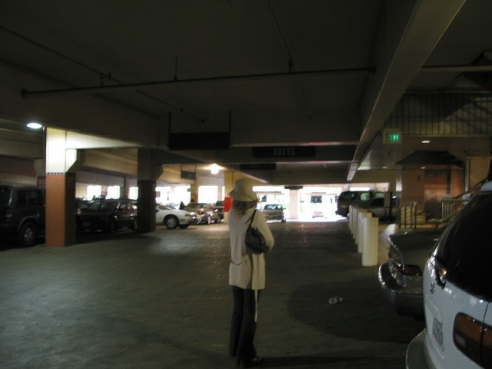

3) Homework\Hunter XP\C\Documents and Settings\Bob Hunter\Local Settings\Application Data\Microsoft\CD Burning\Hunter Pics\Sabrina Dewercs\105-0531_IMG.JPG



4) Homework\Hunter XP\C\Documents and Settings\Bob Hunter\Local Settings\Application Data\Microsoft\CD Burning\Hunter Pics\Sabrina Dewercs\105-0546_IMG.JPG



5) Homework\Hunter XP\C\Documents and Settings\Bob Hunter\Local Settings\Application Data\Microsoft\CD Burning\Hunter Pics\Sabrina Dewercs\105-0556_IMG.JPG



6) Homework\Hunter XP\C\Documents and Settings\Bob Hunter\Local Settings\Application Data\Microsoft\CD Burning\Hunter Pics\Sabrina Dewercs\105-0560_IMG.JPG



7) Homework\Hunter XP\C\Documents and Settings\Bob Hunter\Local Settings\Application Data\Microsoft\CD Burning\Hunter Pics\Sabrina Dewercs\105-0564_IMG.JPG

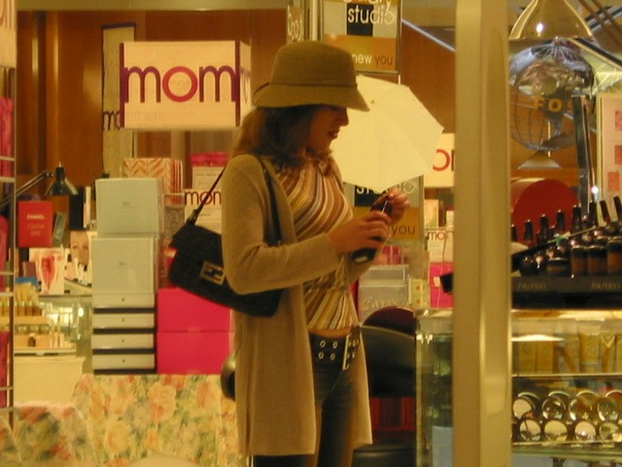

8) Homework\Hunter XP\C\Documents and Settings\Bob Hunter\Local Settings\Application Data\Microsoft\CD Burning\Hunter Pics\Sabrina Dewercs\105-0582_IMG.JPG

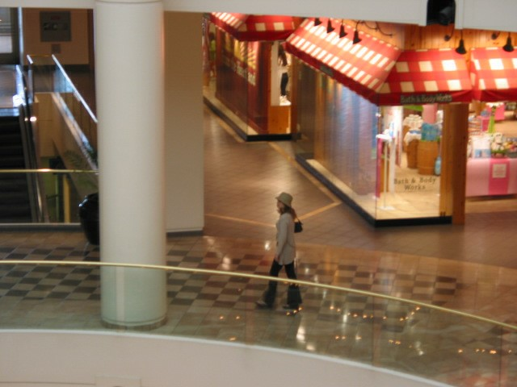

9) Homework\Hunter XP\C\Documents and Settings\Bob Hunter\Local Settings\Application Data\Microsoft\CD Burning\Hunter Pics\Sabrina Dewercs\105-0507_IMG.JPG

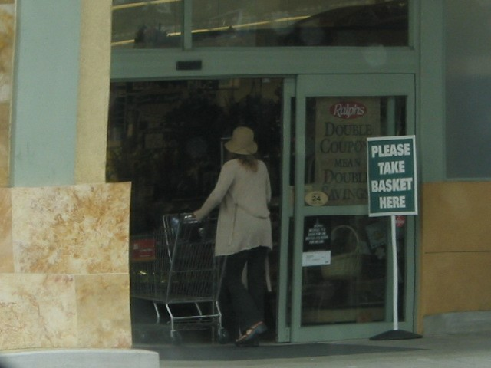

10) Homework\Hunter XP\C\Documents and Settings\Bob Hunter\Local Settings\Application Data\Microsoft\CD Burning\Hunter Pics\Sabrina Dewercs\105-0519_IMG.JPG

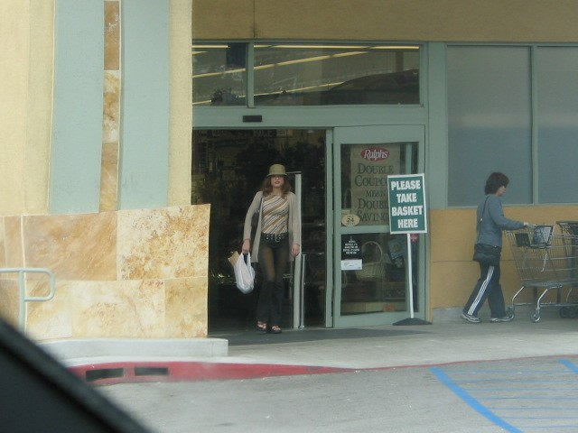

11) Homework\Hunter XP\C\Documents and Settings\Bob Hunter\Local Settings\Application Data\Microsoft\CD Burning\Hunter Pics\Sabrina Dewercs\105-0527_IMG.JPG



12) Homework\Hunter XP\C\Documents and Settings\Bob Hunter\Local Settings\Application Data\Microsoft\CD Burning\Hunter Pics\Sabrina Dewercs\105-0538_IMG.JPG

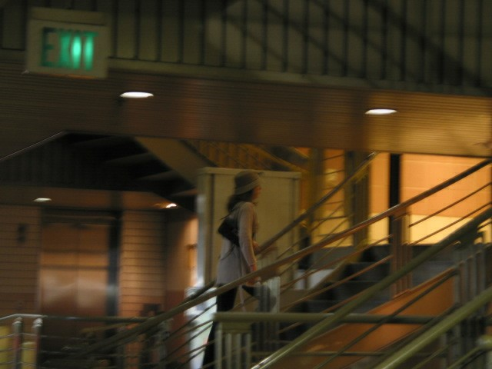

13) Homework\Hunter XP\C\Documents and Settings\Bob Hunter\Local Settings\Application Data\Microsoft\CD Burning\Hunter Pics\Sabrina Dewercs\105-0549_IMG.JPG



14) Homework\Hunter XP\C\Documents and Settings\Bob Hunter\Local Settings\Application Data\Microsoft\CD Burning\Hunter Pics\Sabrina Dewercs\106-0612_IMG.JPG



15) Homework\Hunter XP\C\Documents and Settings\Bob Hunter\Local Settings\Application Data\Microsoft\CD Burning\Hunter Pics\Sabrina Dewercs\102-0294_IMG.JPG

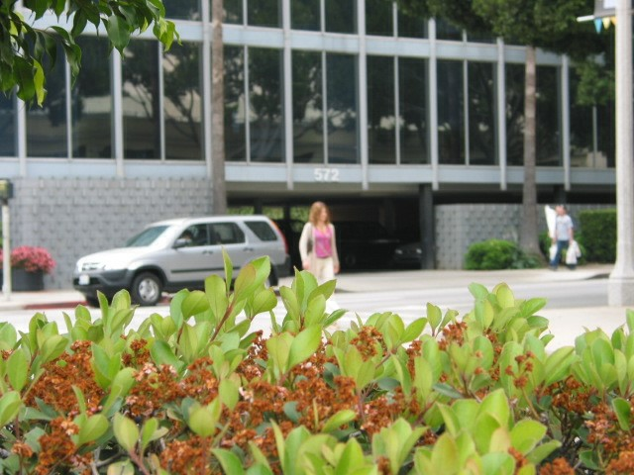

16) Homework\Hunter XP\C\Documents and Settings\Bob Hunter\Local Settings\Application Data\Microsoft\CD Burning\Hunter Pics\Sabrina Dewercs\106-0626_IMG.JPG

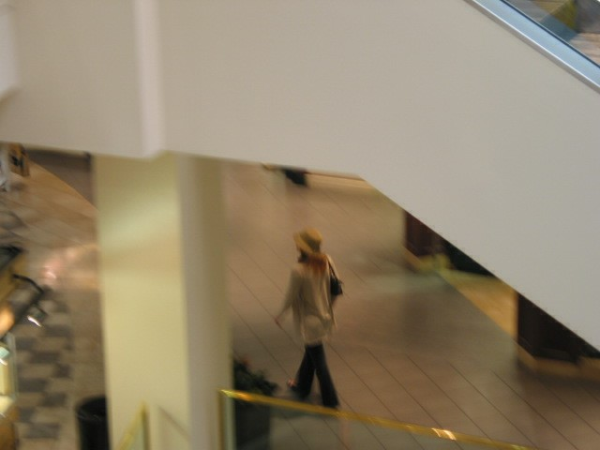

17) Homework\Hunter XP\C\Documents and Settings\Bob Hunter\Local Settings\Application Data\Microsoft\CD Burning\Hunter Pics\Sabrina Dewercs\106-0638_IMG.JPG



18) Homework\Hunter XP\C\Documents and Settings\Bob Hunter\Local Settings\Application Data\Microsoft\CD Burning\Hunter Pics\Sabrina Dewercs\106-0637_IMG.JPG



19) Homework\Hunter XP\C\Documents and Settings\Bob Hunter\Local Settings\Application Data\Microsoft\CD Burning\Hunter Pics\Sabrina Dewercs\103-0347_IMG.JPG

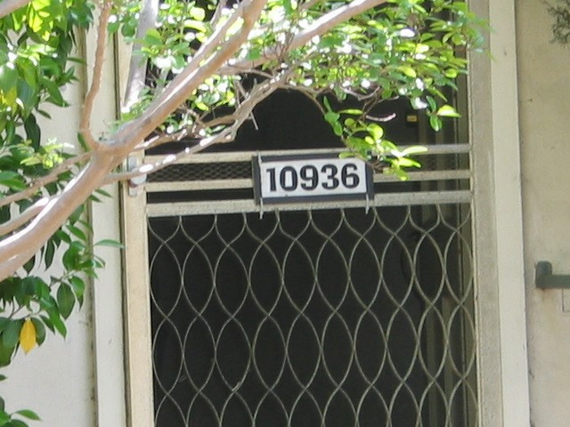

20) Homework\Hunter XP\C\Documents and Settings\Bob Hunter\Local Settings\Application Data\Microsoft\CD Burning\Hunter Pics\Sabrina Dewercs\103-0345_IMG.JPG

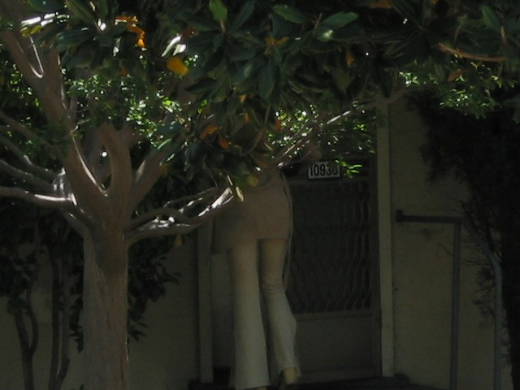

21) Homework\Hunter XP\C\Documents and Settings\Bob Hunter\Local Settings\Application Data\Microsoft\CD Burning\Hunter Pics\Sabrina Dewercs\103-0357_IMG.JPG



22) Homework\Hunter XP\C\Documents and Settings\Bob Hunter\Local Settings\Application Data\Microsoft\CD Burning\Hunter Pics\Sabrina Dewercs\103-0352_IMG.JPG

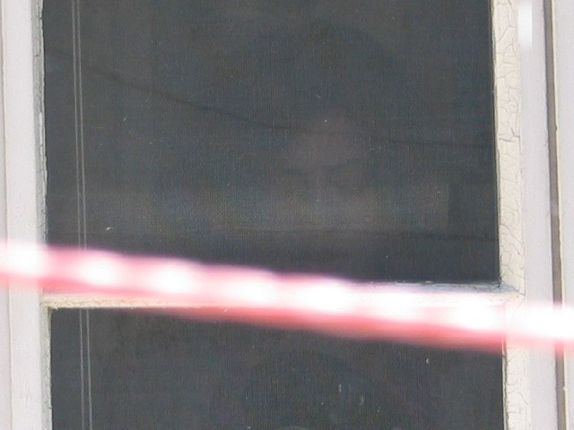

23) Homework\Hunter XP\C\Documents and Settings\Bob Hunter\Local Settings\Application Data\Microsoft\CD Burning\Hunter Pics\Sabrina Dewercs\103-0361_IMG.JPG

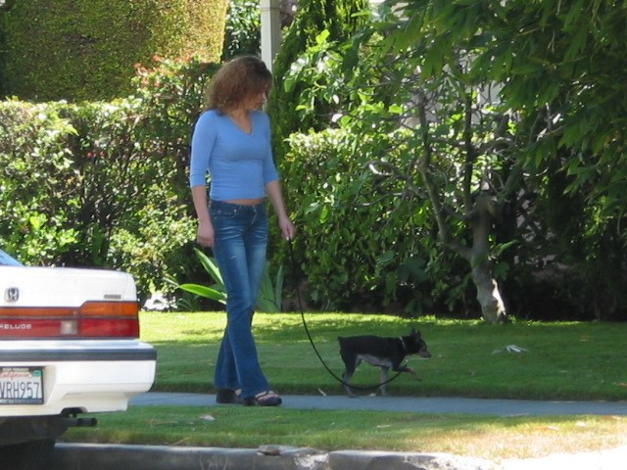

24) Homework\Hunter XP\C\Documents and Settings\Bob Hunter\Local Settings\Application Data\Microsoft\CD Burning\Hunter Pics\Sabrina Dewercs\103-0365_IMG.JPG



25) Homework\Hunter XP\C\Documents and Settings\Bob Hunter\Local Settings\Application Data\Microsoft\CD Burning\Hunter Pics\Sabrina Dewercs\103-0318_IMG.JPG



26) Homework\Hunter XP\C\Documents and Settings\Bob Hunter\Local Settings\Application Data\Microsoft\CD Burning\Hunter Pics\Sabrina Dewercs\103-0339_IMG.JPG

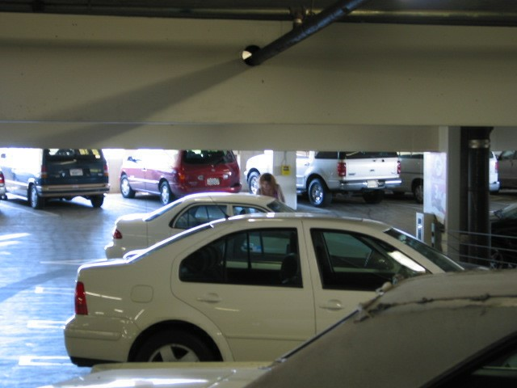

27) Homework\Hunter XP\C\Documents and Settings\Bob Hunter\Local Settings\Application Data\Microsoft\CD Burning\Hunter Pics\Sabrina Dewercs\103-0349_IMG.JPG



28) Homework\Hunter XP\C\Documents and Settings\Bob Hunter\Local Settings\Application Data\Microsoft\CD Burning\Hunter Pics\Sabrina Dewercs\104-0425_IMG.JPG



29) Homework\Hunter XP\C\Documents and Settings\Bob Hunter\Local Settings\Application Data\Microsoft\CD Burning\Hunter Pics\Sabrina Dewercs\104-0480_IMG.JPG

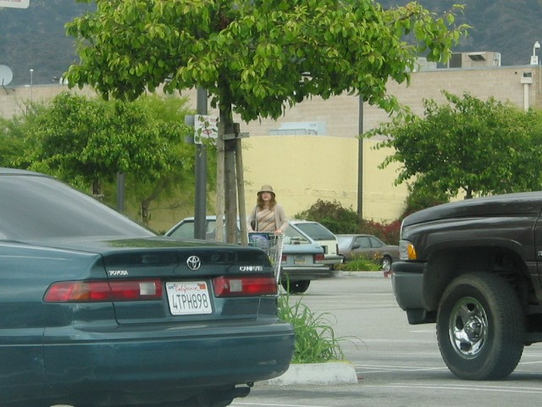

30) Homework\Hunter XP\C\Documents and Settings\Bob Hunter\Local Settings\Application Data\Microsoft\CD Burning\Hunter Pics\Sabrina Dewercs\104-0484_IMG.JPG

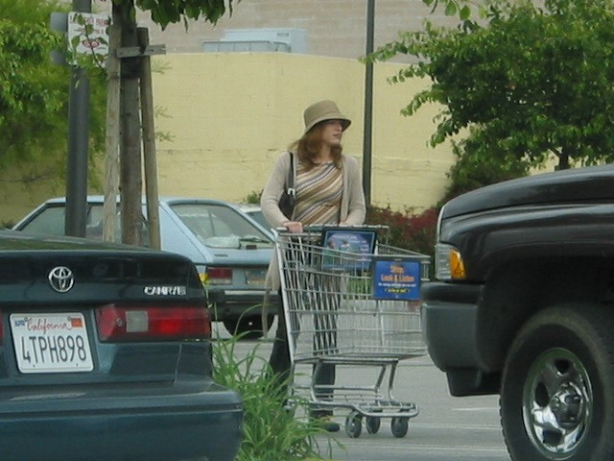

31) Homework\Hunter XP\C\Documents and Settings\Bob Hunter\Local Settings\Application Data\Microsoft\CD Burning\Hunter Pics\Sabrina Dewercs\104-0494_IMG.JPG

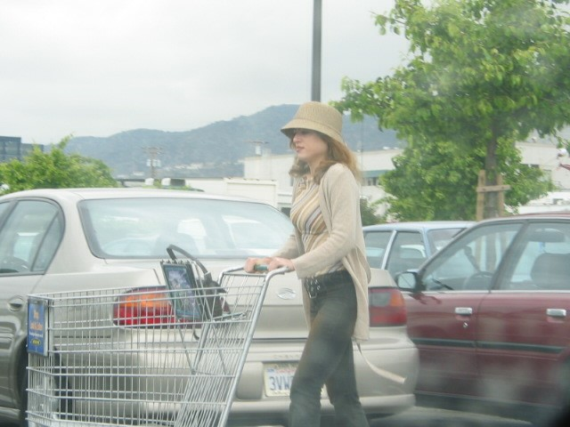

32) Homework\Hunter XP\C\Documents and Settings\Bob Hunter\Local Settings\Application Data\Microsoft\CD Burning\Hunter Pics\Sabrina Dewercs\104-0496_IMG.JPG

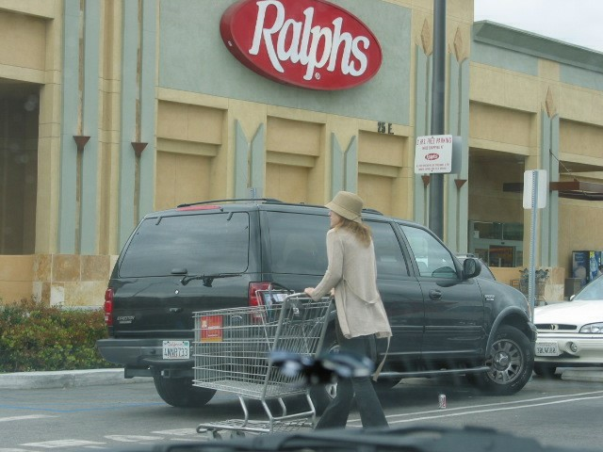

33) Homework\Hunter XP\C\Documents and Settings\Bob Hunter\Local Settings\Temporary Internet Files\Content.IE5\042WFPGU\105-0527_IMG[1].jpg



1) Homework\Hunter XP\C\Documents and Settings\Bob Hunter\Local Settings\Application Data\Microsoft\CD Burning\Hunter Pics\Sabrina and Christina

Main folder in which are stored the pictures of Sabrina Dewercs and Christina Detsiwt

2) Homework\Hunter XP\C\Documents and Settings\Bob Hunter\Local Settings\Application Data\Microsoft\CD Burning\Hunter Pics\Sabrina and Christina\104-0430_IMG.JPG



3) Homework\Hunter XP\C\Documents and Settings\Bob Hunter\Local Settings\Application Data\Microsoft\CD Burning\Hunter Pics\Sabrina and Christina\103-0330_IMG.JPG



4) Homework\Hunter XP\C\Documents and Settings\Bob Hunter\Local Settings\Application Data\Microsoft\CD Burning\Hunter Pics\Sabrina and Christina\103-0331_IMG.JPG



5) Homework\Hunter XP\C\Documents and Settings\Bob Hunter\Local Settings\Application Data\Microsoft\CD Burning\Hunter Pics\Sabrina and Christina\103-0337_IMG.JPG



6) Homework\Hunter XP\C\Documents and Settings\Bob Hunter\Local Settings\Application Data\Microsoft\CD Burning\Hunter Pics\Sabrina and Christina\103-0334_IMG.JPG



7) Homework\Hunter XP\C\Documents and Settings\Bob Hunter\Local Settings\Application Data\Microsoft\CD Burning\Hunter Pics\Sabrina and Christina\103-0333_IMG.JPG



8) Homework\Hunter XP\C\Documents and Settings\Bob Hunter\Local Settings\Application Data\Microsoft\CD Burning\Hunter Pics\Sabrina and Christina\104-0426_IMG.JPG



9) Homework\Hunter XP\C\Documents and Settings\Bob Hunter\Local Settings\Application Data\Microsoft\CD Burning\Hunter Pics\Sabrina and Christina\104-0427_IMG.JPG



**PART 2: Information Technology**

**TASK 1**

**1.1 Explain the difference between DHM (Diffie-Hellman-Merkle) and RSA using diagram and mathematical formulas whenever possible. Give the reason why RSA is hard to break.**

The mathematical problems are similar but different as well. Both of them make use of modular exponentiation so that their work is different. Each of them has threats such as integer factorization for the RSA and discrete logarithms for Diffie-Hellman. Diffie-Hellman is also a key exchange algorithm which is not the same with public key encryption since this allows two persons arrive at the same piece of information and not everybody else. The public key encryption is when you select a message that both of the parties are aware of.

**1.2** **Show the working steps on calculating a shared key for a secret cipher using the DHM with parameters p=7 and g=4 and implement it in python.**

In the Diffie-Hellman algorithm there is a prime number that is fixed (p) and a base (g). Alice and Bob then choose a secret number each (a and b) which would come into the equation which based on the key each of them picked would give the shared key, in our case 2.

a = 5

Alice = ga mod p = 45 mod 7 = 2

b = 7

Bob = gb mod p = 47 mod 7 = 4

keya = Bob a mod p = 45 mod 7 = 2

keyb = Alice B mod p = 27 mod 7 = 2

**TASK 2**

**2.1** **In RSA, let e=5, n=55. Can you find d ≡ 1/e (mod ϕ(n))? Why?**

In RSA if we have e and n then we have the encryption key which is the most important so if we would like to have the decryption key d then we can calculate the equation. The problem with our example here is that e and phi(n) are not coprime which make d non-existent

**2.2 Let e=13, n=55. Find d ≡ 1/e (mod ϕ(n)) provided that d exists. If d does not exist, explain the reason of the nonexistence of d.**

Euler's totient function φ(n) is the number of positive integers not exceeding n that do not have any common divisors with n. In our case φ (55) is giving us a result of 40. Since e and phi are coprime, e being equal to 13 and phi of 55 being equal to 40, d will be equal to 37

**2.3 Given the RSA public key (3,70747) and private key (46811,70747)**

**Encrypt the letter ‘z’ using its ASCII value.**

Z letter encrypted: **0x20 0x1b 0x73**

90, z ASCII number encrypted: **0x2f 0x26 0x6c**

**TASK 4**

**4.1 Critically compare, analyse and evaluate three authentication protocols including Needham-Schroeder protocol, Otway Rees, Kerberos.**

**Needham-Schroeder Protocol**

**In order to define and explain the Needham-Schroeder protocol we will have some notations which will make it easier for us to understand the process.**

There are two machines: A and B.

Symmetric Key known as man Server ‘S’ to machine A: SK(AS)

Symmetric Key known as man Server ‘S’ to machine A: SK(BS)

Nonce generated by machine A: NON(A)

Nonce generated by machine B: NON(B)

Symmetric session key generated by the server for both machines: SK(S)

**Process**

1. A machine A sends a message to server S saying it wants to communicate with machine B
2. Server S sends a message back to A containing: SK(S), SK(S) copy encrypted with SK(BS) which will be sent to B by A
3. A sends SK(S) to B that can be decrypted by the key encrypted by middle man server with B symmetric key SK(BS)
4. B sends to A nonce encrypted by SK(S) to confirm the symmetric key confirmation by the middle man server.
5. A perform operation on nonce provided by B and sends back to B to verify that A has the key

**Otway Rees**

**Process**

1. A sends message to B that has a nonce R + challenge RA + ticket to KDC containing R and RA. The ticket is encrypted with A secret key.
2. B creates ticket with his nonce RB then sends both tickets to KDC
3. B sends A her ticket
4. A sends short message encrypted with B session key

**Kerberos**

1. Client request authentication ticket from KDC
2. KDC verify credentials and sends back an encrypted TGT ticket and session key
3. TGT is encrypted using TGS secret key
4. Client stores TGT and when the session manager says that it expires, it will request another one from TGT which is a transparent process for the user

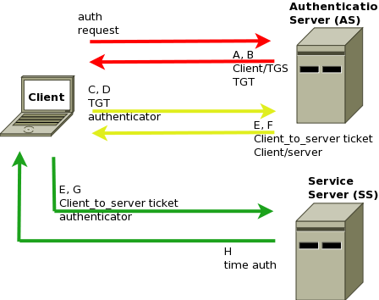

(https://en.wikipedia.org/wiki/Authentication_protocol#/media/File:Kerberos_sch_en.png)

All of the protocols presented above have multiple elements in common which are keeping the communication between the Key Distribution Centre and the machines in order to secure the network. Nonces are elements that appear in the equation since the channel has to appear ‘online’ to the server which is an essential part. They are centralized and checked by the server so that machines are genuine and also there are multiple clients available in the network which make use of the different protocols.

**4.2 Given Alice wants to communicate with Bob over an insecure network, you are required to 1) design a protocol based on a shared secret key to allow them to authenticate each other; 2) Explain the limitation of using the shared secret key in this context.**

The problem with the shared key encryption is the fact that there can be attackers that would use different approaches to hack the key, some of these are brute force key search which takes basically all the possibilities, but the downside of it is the fact that it takes countless number of hours to break such a shared key, even years with as much computing power as someone has. The other technique is the mathematical attacks that are based on the difficulty of computing the factor modulus n.